Project Images
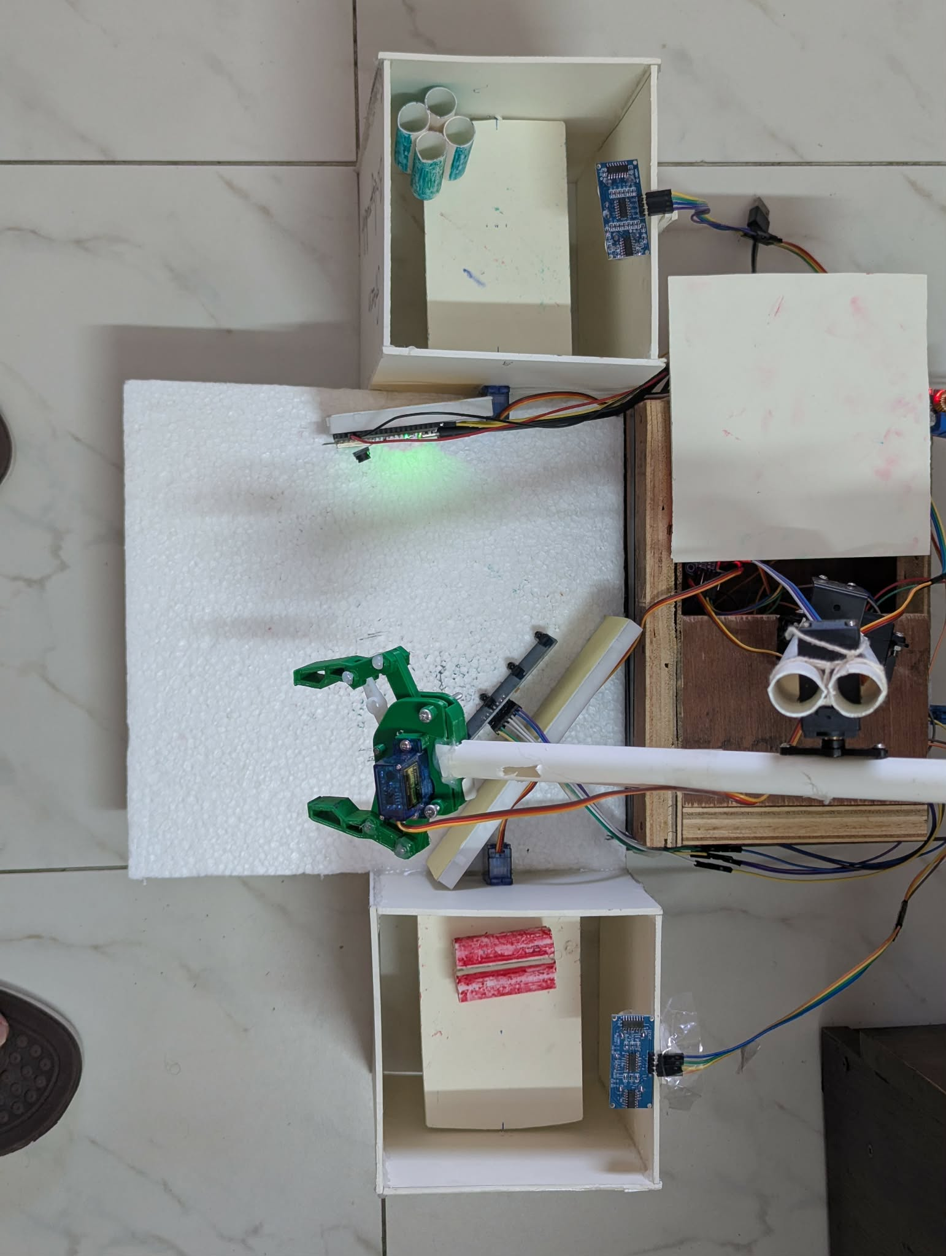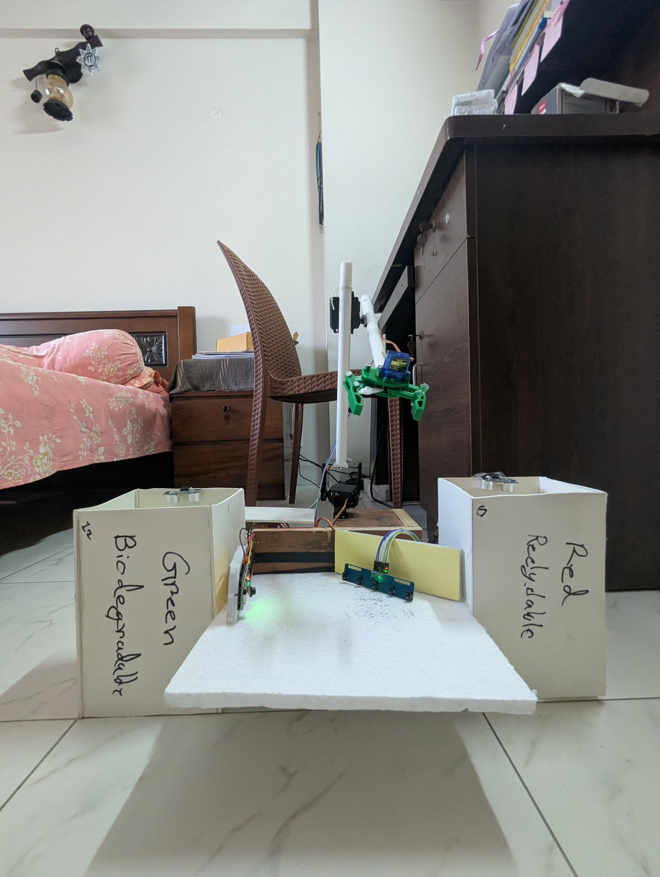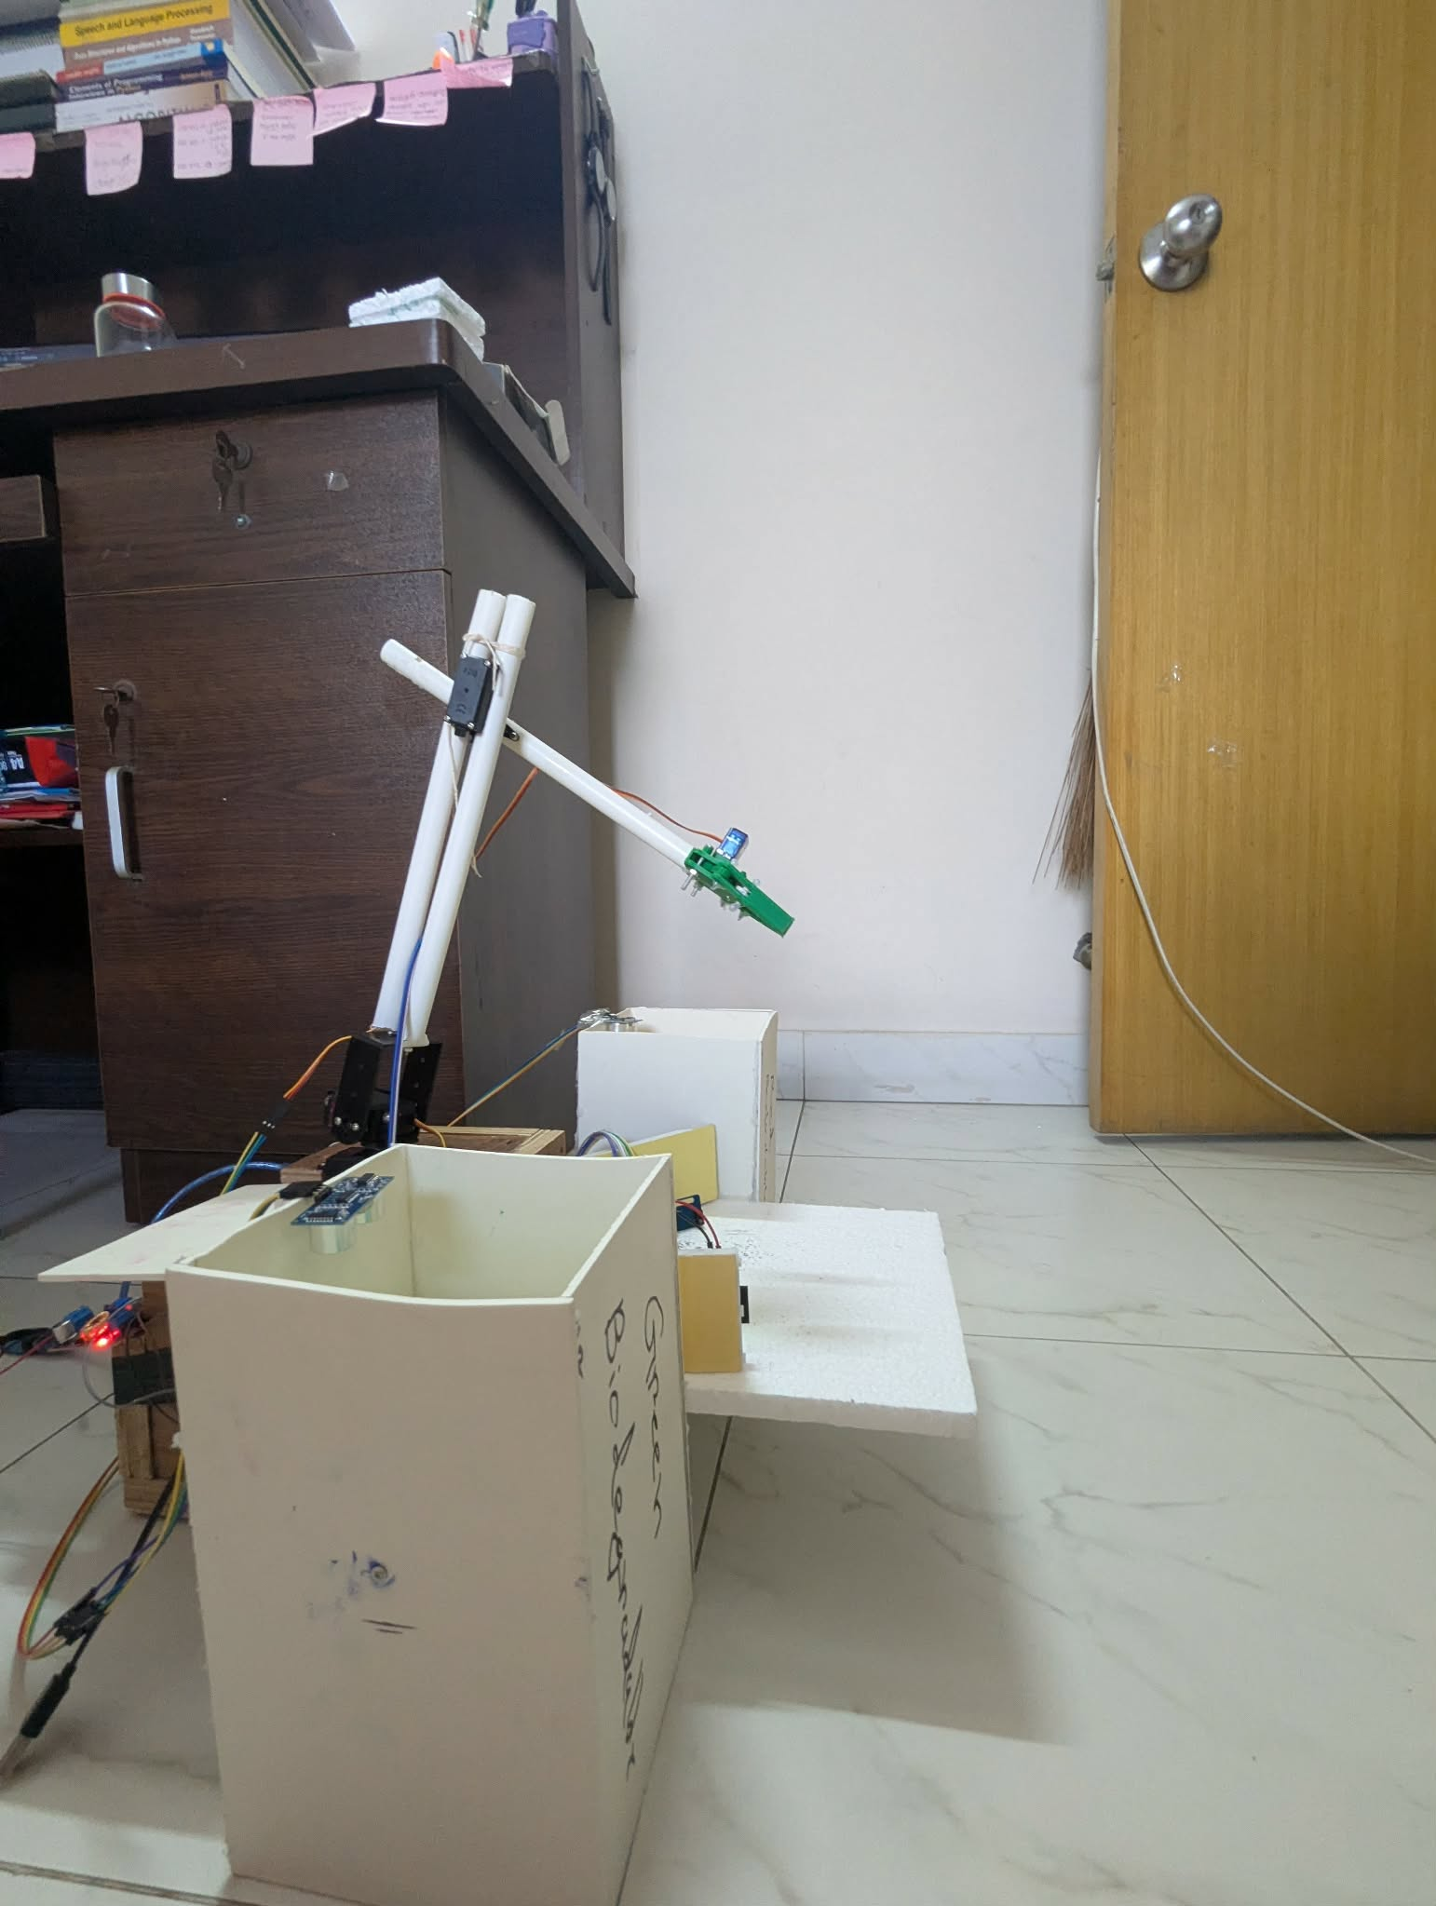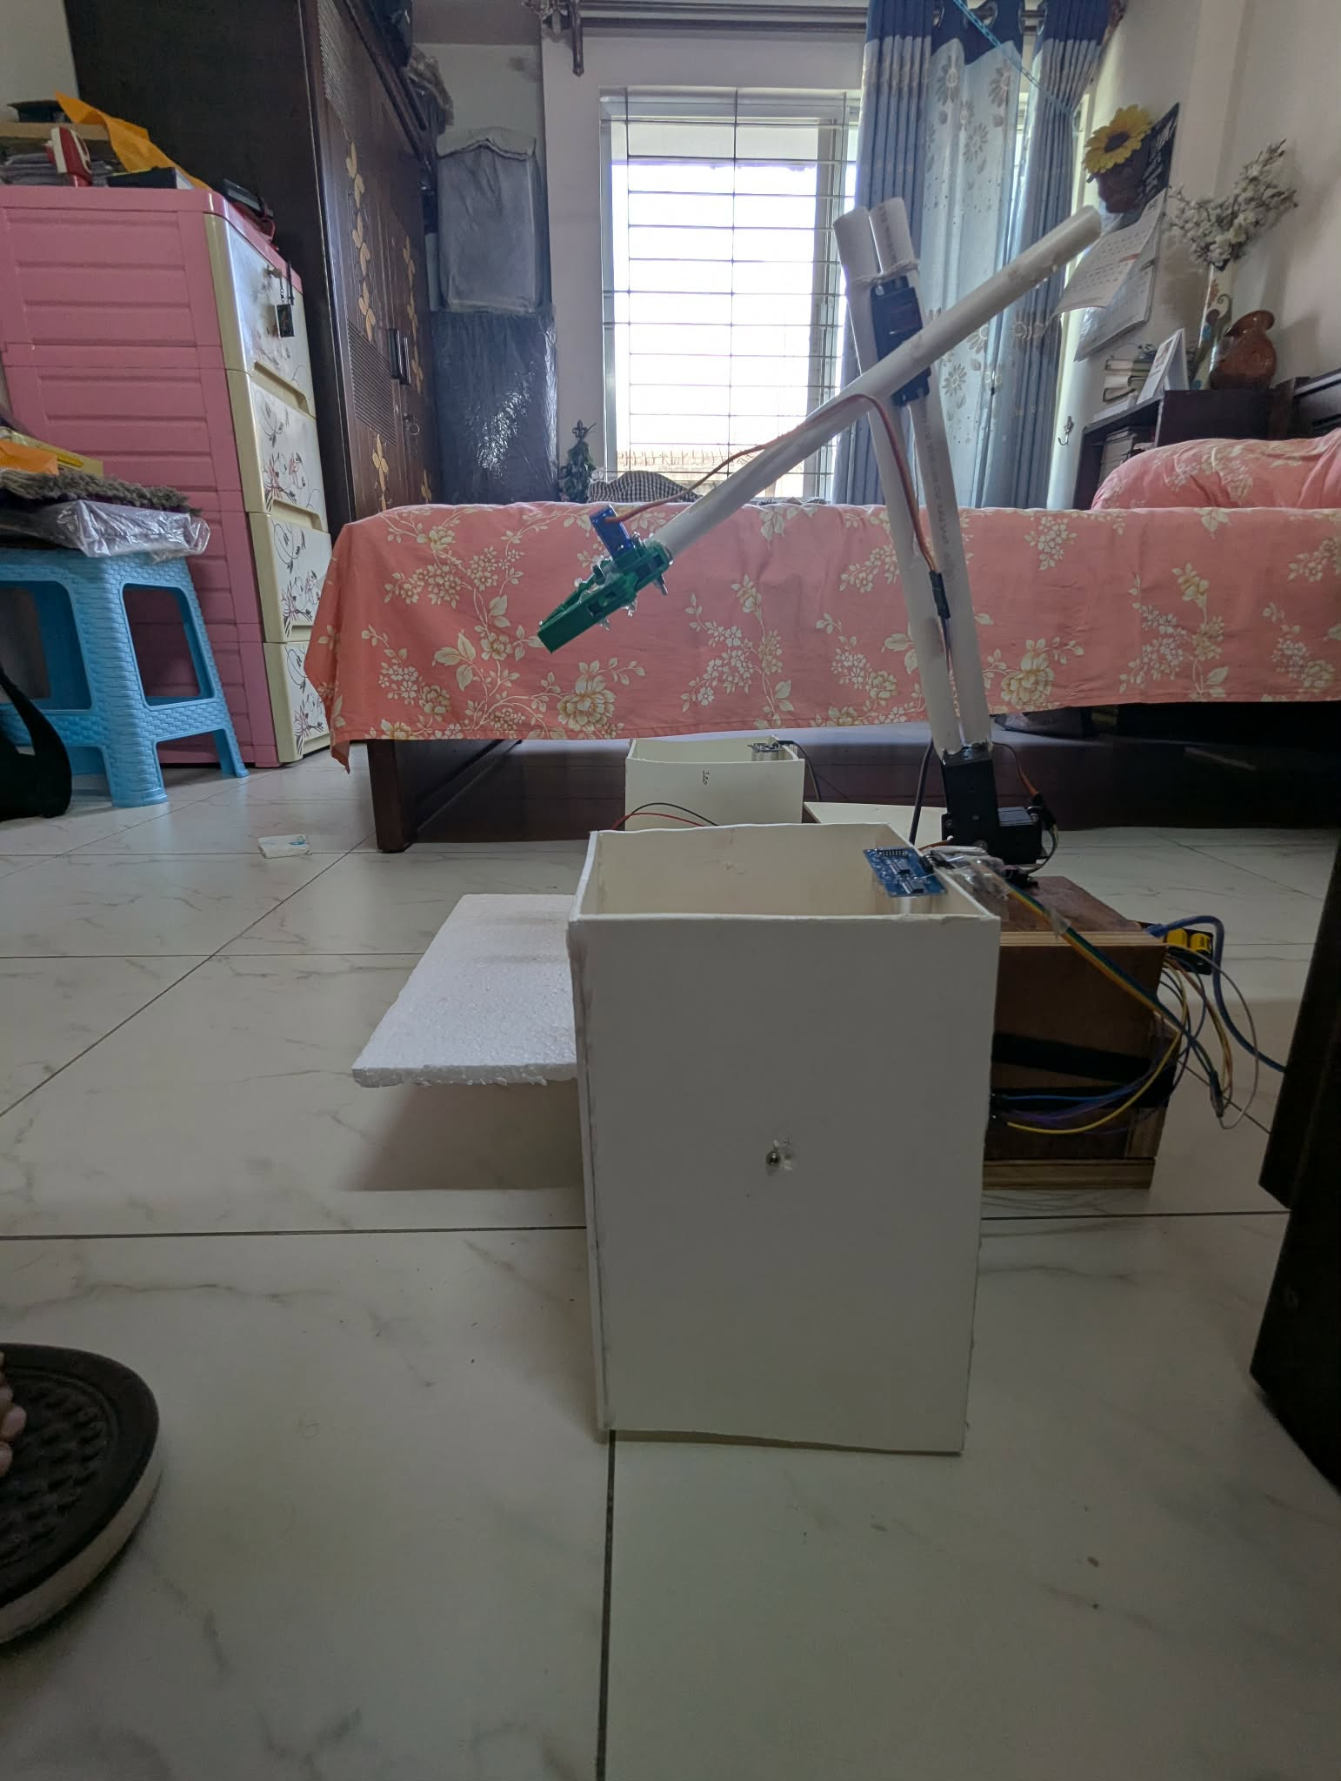

Demonstration Video
Demonstration Video
SmartSort Demonstration Video (CSE461 Project).MOV

Web Dashboard (http://10.179.161.248/)

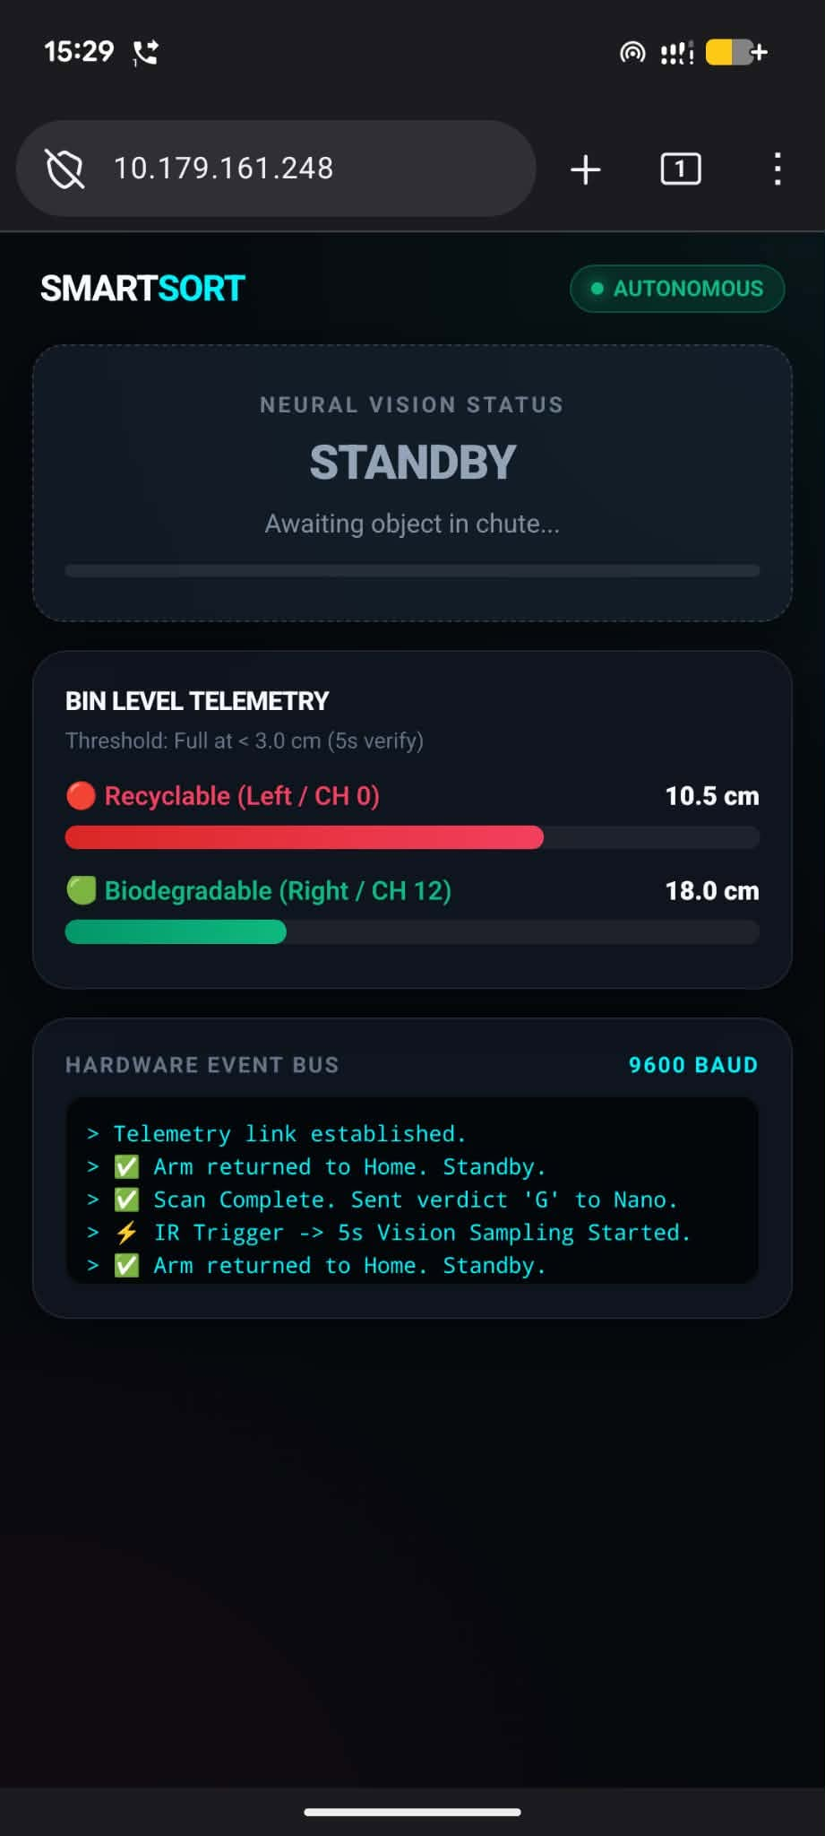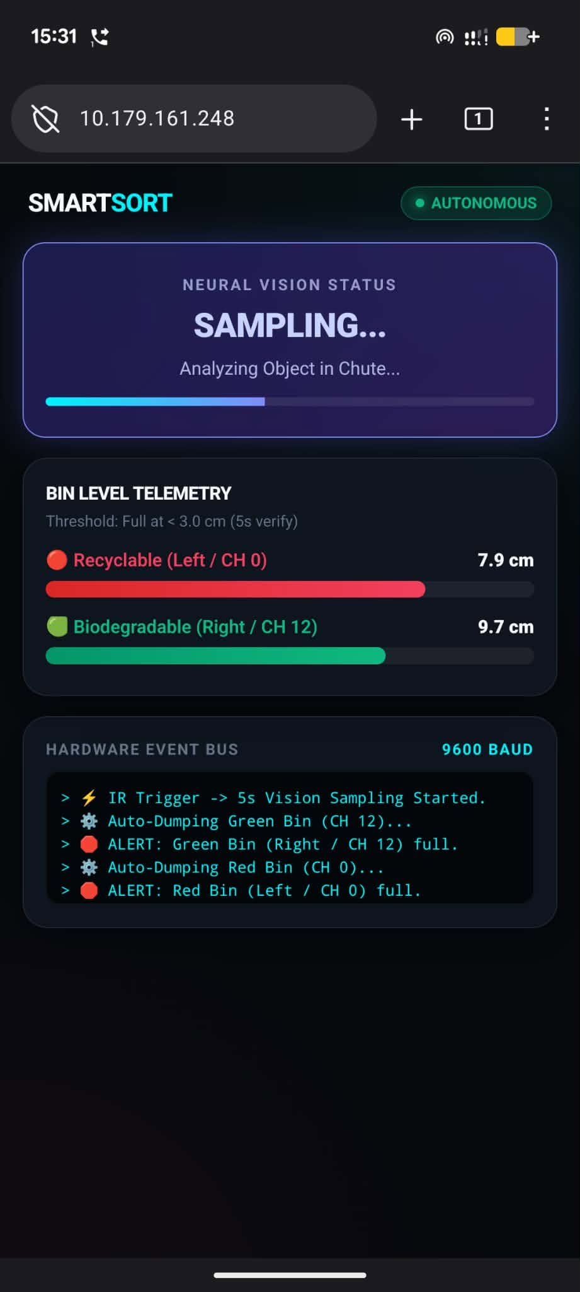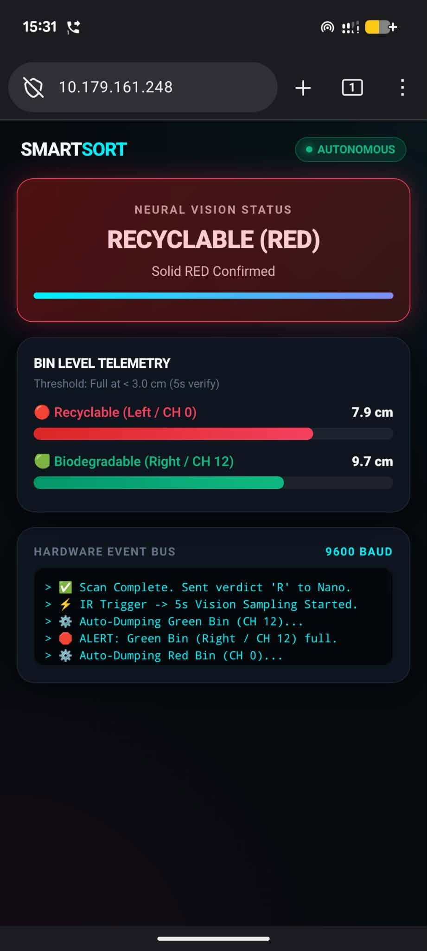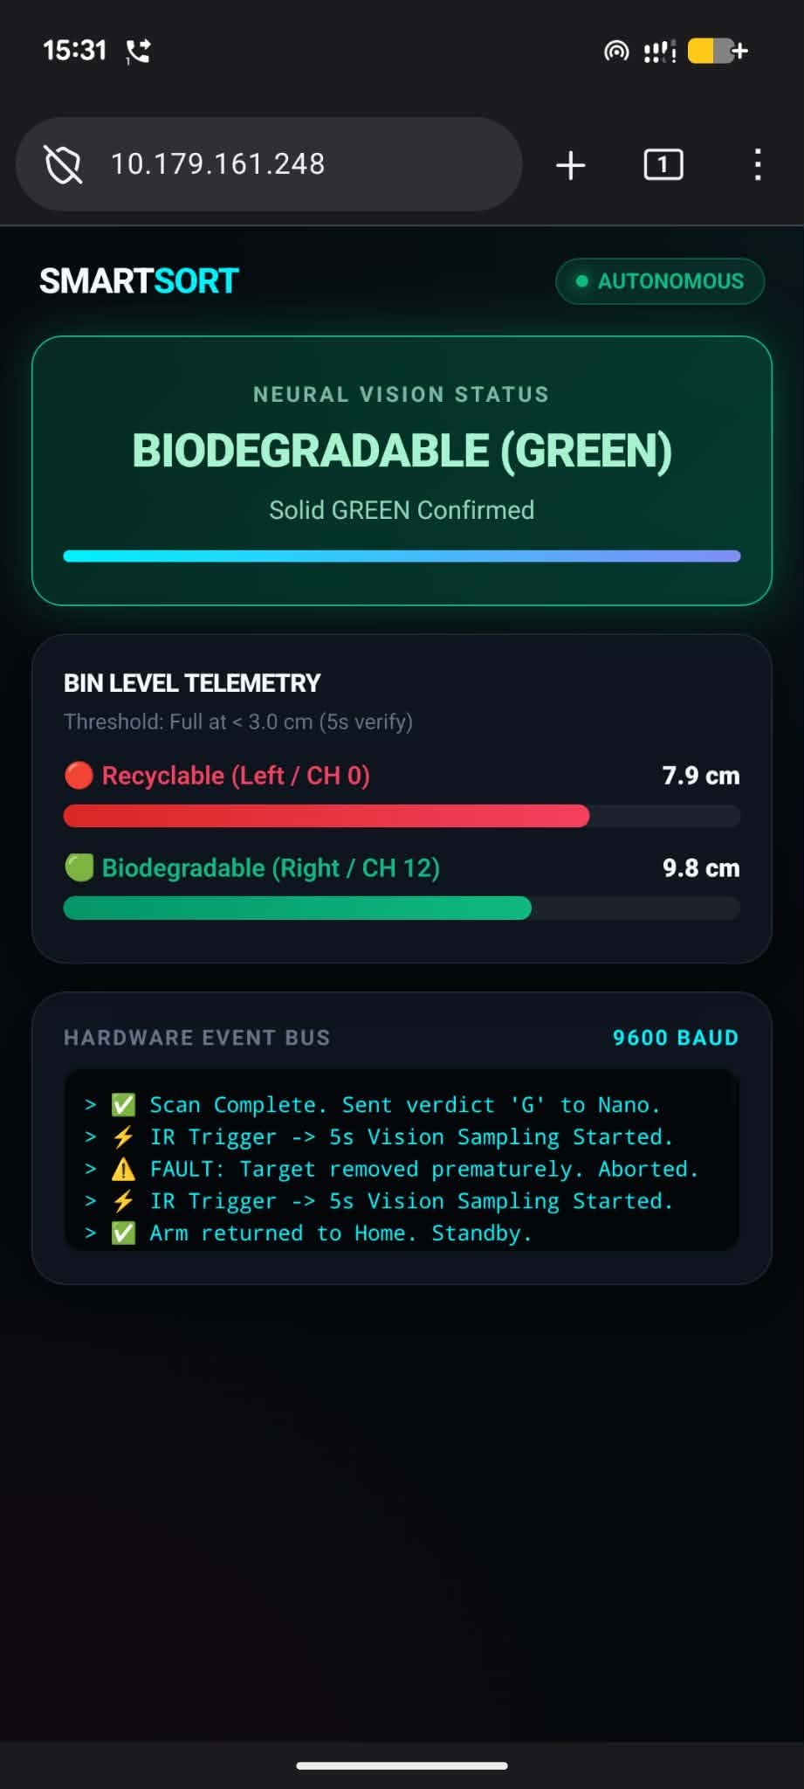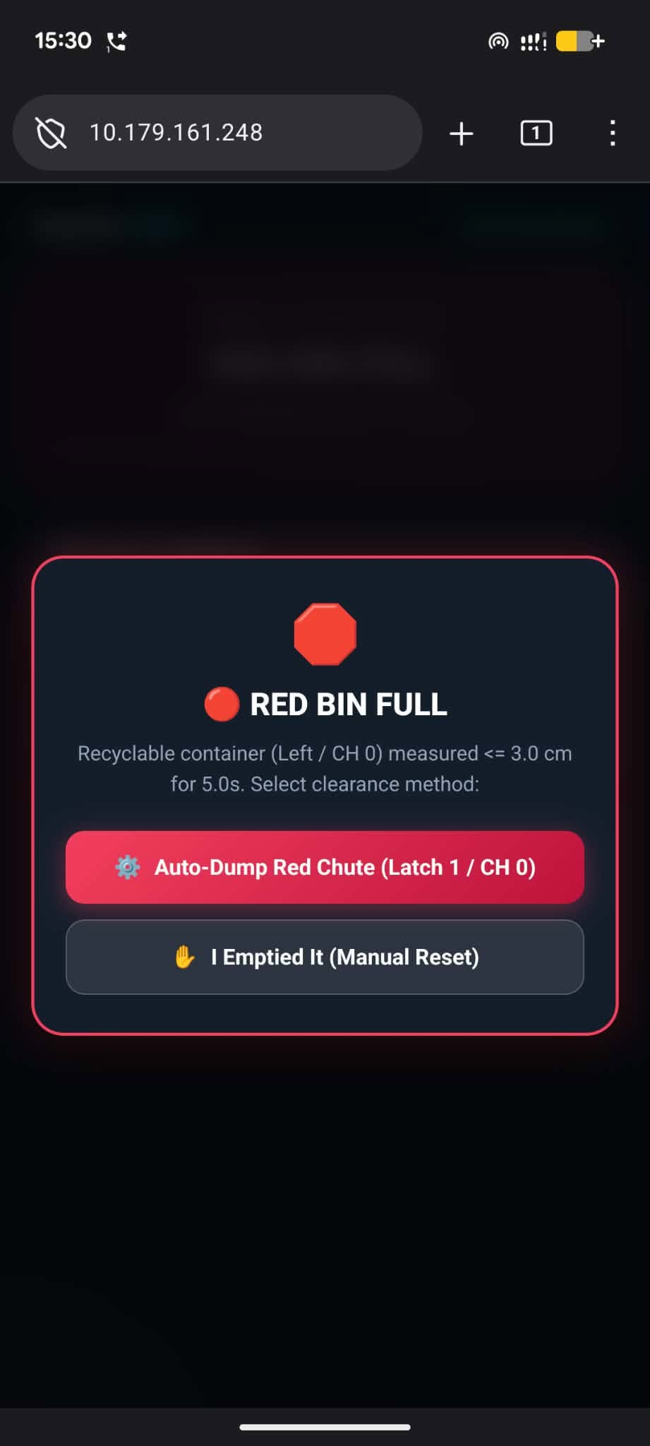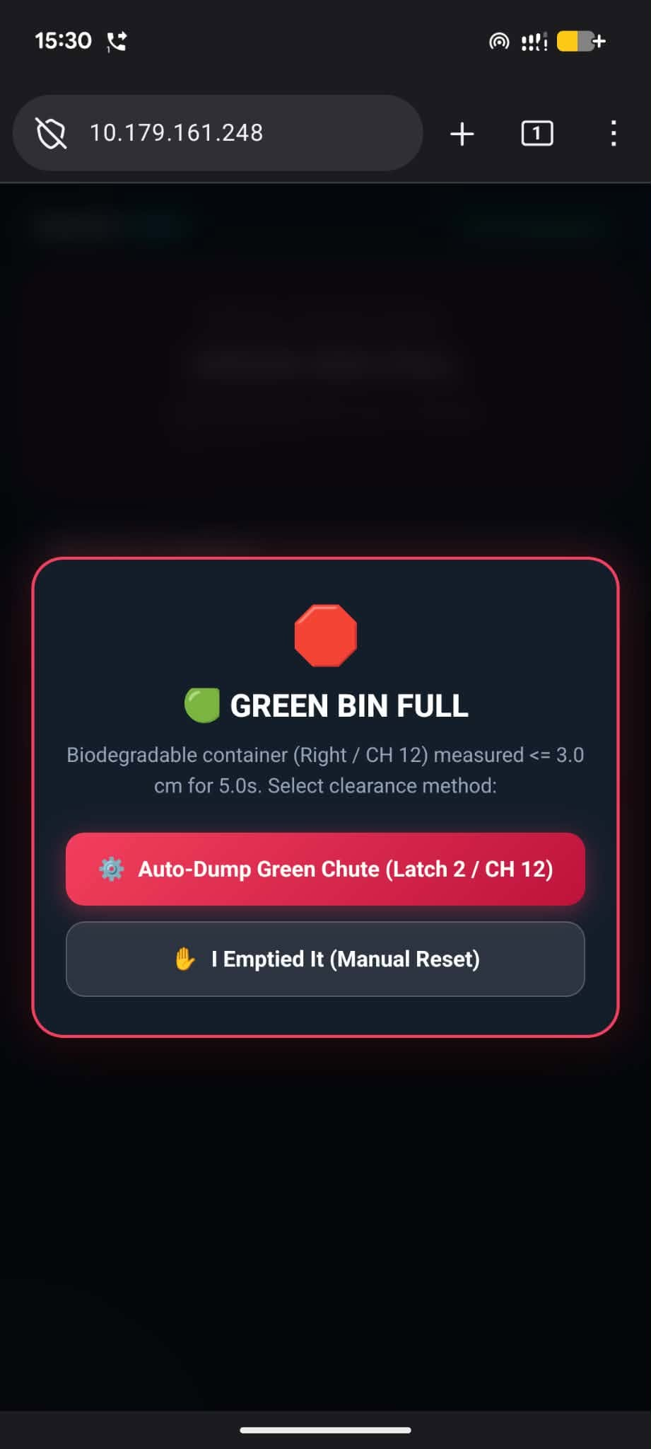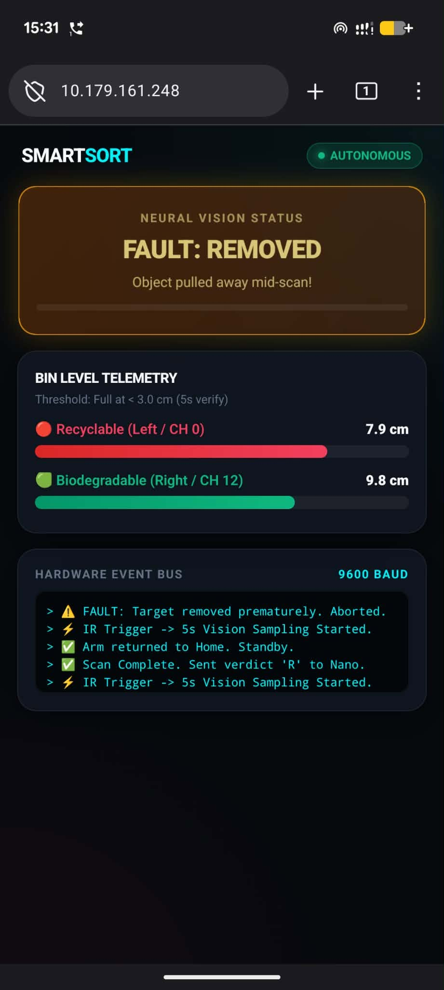

Pin Layout

Arduino Nano
IR 5-Array Panel Sensor: D8 - D12
Ultrasonic Left Bin:
D2: Trig
D3: Echo
Ultrasonic Right Bin:
D4: Trig
D5: Echo
ESP32S3 Communication:
D6 (RX): GPIO 2 (TX)
D7 (TX): GPIO 1 (RX)

Servo Driver Layout
CH 0: Left Bin Servo
CH 12: Right Bin Servo
CH 10: ARM
CH 11: Elbow
CH 4: Base
CH 1: Gripper

Robotic ARM Measurements
CH 0:
Max Ticks: 470
Base: x45
Latch Open: x120
CH 12:
Max Ticks: 470
Base: y145
Latch Open: y70

Initial Position:
b70
a170
e45
G70
Picking Position:
e65
a132
g180(gripped)

Bin Right (Green):
a170
e45
b10
g70 (Release)

Bin Left (Red):
a170
e45
b110
g70 (Release)

Back to Initial

Servo Adjustment Code
#include <Wire.h>
#include <Adafruit_PWMServoDriver.h>

Adafruit_PWMServoDriver pwm = Adafruit_PWMServoDriver(0x40);

// --- Joint Configuration Structure with Independent Tick Bounds ---
struct Joint {
uint8_t channel; // PCA9685 Channel
char cmdLetter; // Single-letter command
const char* name; // Display name
int minTicks; // Individual 0 deg pulse limit
int maxTicks; // Individual 180 deg pulse limit
int currentAngle; // Current angle tracker
int homeAngle; // Default home position
int stepDelay; // Speed in ms per degree (Lower = Faster)
bool isRelaxed; // Power status
};

// 6 Servos with calibrated tick limits and updated initial positions
Joint joints[] = {
// ch, cmd, name, minT, maxT, initA, homeA, stepDelay, isRelaxed
{ 4, 'b', "Base", 150, 550, 70, 70, 15, false }, // MG996R (CH 4)
{ 10, 'a', "Arm", 150, 550, 170, 170, 15, false }, // MG996R (CH 10)
{ 11, 'e', "Elbow", 150, 500, 45, 45, 15, false }, // SG90/MG996R (CH 11)
{ 1, 'g', "Gripper", 150, 500, 70, 70, 8, false }, // Gripper (CH 1)
{ 0, 'x', "SG90 Latch 1", 140, 470, 50, 50, 6, false }, // SG90 (CH 0: Max 470, Home 50, Open 140)
{ 12, 'y', "SG90 Latch 2", 140, 470, 145, 145, 6, false } // SG90 (CH 12: Max 470, Home 145, Open 20)
};

const int NUM_JOINTS = sizeof(joints) / sizeof(joints[0]);

// Pick & Place Keypoints
const int PICK_ELBOW = 65; // Extended first
const int PICK_ARM = 132; // Lowered second
const int GRIP_CLOSE = 180;
const int GRIP_OPEN = 70;
const int DROP_BASE_G = 10; // Green Bin
const int DROP_BASE_R = 110; // Red Bin

// Latch Positions
const int LATCH1_HOME = 50;
const int LATCH1_OPEN = 140;
const int LATCH2_HOME = 145;
const int LATCH2_OPEN = 20;

void setup() {
Serial.begin(9600);
Wire.begin();

#if defined(WIRE_HAS_TIMEOUT)
Wire.setWireTimeout(3000, true);
#endif

pwm.begin();
pwm.setPWMFreq(50);
delay(100);

// Initialize all servos to home positions
for (int i = 0; i < NUM_JOINTS; i++) {
setServoAngle(joints[i], joints[i].homeAngle);
joints[i].currentAngle = joints[i].homeAngle;
joints[i].isRelaxed = false;
}

printHelpMenu();
}

void loop() {
if (Serial.available() > 0) {
String input = Serial.readStringUntil('\n');
input.trim();
if (input.length() == 0) return;

// 1. Automated Sorting Sequences ('g' for Green b10, 'r' for Red b110)
if (input.equalsIgnoreCase("g")) {
executePickAndPlace("GREEN BIN (Drop at b10)", DROP_BASE_G);
return;
}
if (input.equalsIgnoreCase("r")) {
executePickAndPlace("RED BIN (Drop at b110)", DROP_BASE_R);
return;
}

// 2. Return All to Home ('h')
if (input.equalsIgnoreCase("h") || input.equalsIgnoreCase("home")) {
goHomeAll();
return;
}

// 3. Quick Latch Helper Commands (open/close)
if (input.equalsIgnoreCase("x open")) {
moveJoint(joints[4], LATCH1_OPEN);
return;
}
if (input.equalsIgnoreCase("x close")) {
moveJoint(joints[4], LATCH1_HOME);
return;
}
if (input.equalsIgnoreCase("y open")) {
moveJoint(joints[5], LATCH2_OPEN);
return;
}
if (input.equalsIgnoreCase("y close")) {
moveJoint(joints[5], LATCH2_HOME);
return;
}

// 4. Live Calibration: Set Max Ticks on the fly (e.g. "max 0 470", "max 12 470")
if (input.startsWith("max ")) {
String params = input.substring(4);
params.trim();
int spaceIdx = params.indexOf(' ');
if (spaceIdx > 0) {
int ch = params.substring(0, spaceIdx).toInt();
int newMax = params.substring(spaceIdx + 1).toInt();
for (int i = 0; i < NUM_JOINTS; i++) {
if (joints[i].channel == ch) {
joints[i].maxTicks = newMax;
Serial.print(F("[CALIBRATED] "));
Serial.print(joints[i].name);
Serial.print(F(" (CH "));
Serial.print(ch);
Serial.print(F(") maxTicks set to: "));
Serial.println(newMax);
setServoAngle(joints[i], joints[i].currentAngle);
return;
}
}
}
Serial.println(F("[ERROR] Format: max <channel> <ticks> (e.g. max 0 470)"));
return;
}

// 5. Live Calibration: Direct Raw Ticks Test (e.g. "t 0 350", "t 12 470")
if (input.startsWith("t ") && input.length() > 2) {
String param = input.substring(2);
param.trim();
int spaceIdx = param.indexOf(' ');
if (spaceIdx > 0) {
int ch = param.substring(0, spaceIdx).toInt();
int targetTicks = param.substring(spaceIdx + 1).toInt();
for (int i = 0; i < NUM_JOINTS; i++) {
if (joints[i].channel == ch) {
targetTicks = constrain(targetTicks, 100, 650);
pwm.setPWM(joints[i].channel, 0, targetTicks);
Serial.print(F("[RAW TICKS] CH "));
Serial.print(joints[i].channel);
Serial.print(F(" -> "));
Serial.println(targetTicks);
return;
}
}
}
}

// 6. Explicit Power-On Commands (e.g. "on all", "on 0", "on 12", "on b")
if (input.startsWith("on ")) {
String target = input.substring(3);
target.trim();

if (target.equalsIgnoreCase("all")) {
for (int i = 0; i < NUM_JOINTS; i++) {
setServoAngle(joints[i], joints[i].currentAngle);
joints[i].isRelaxed = false;
}
Serial.println(F(">>> [POWER ON] All servos re-engaged and holding."));
} else {
for (int i = 0; i < NUM_JOINTS; i++) {
if (target.equalsIgnoreCase(String(joints[i].channel)) || target.equalsIgnoreCase(String(joints[i].cmdLetter))) {
setServoAngle(joints[i], joints[i].currentAngle);
joints[i].isRelaxed = false;
Serial.print(F("[POWER ON] "));
Serial.print(joints[i].name);
Serial.println(F(" re-engaged and locked."));
break;
}
}
}
return;
}

// 7. Power Saving: Disable All Servos ("off all" or "d all")
if (input.equalsIgnoreCase("off all") || input.equalsIgnoreCase("d all") || input.equalsIgnoreCase("relax all")) {
for (int i = 0; i < NUM_JOINTS; i++) {
disableJoint(joints[i]);
}
Serial.println(F(">>> [POWER SAVE] All servos relaxed (0mA idle)."));
return;
}

// 8. Power Saving: Disable Individual Servo (e.g. "d0", "d12", "dx", "dy")
if (input.startsWith("d") || input.startsWith("off ") || input.startsWith("relax ")) {
String target = input;
if (target.startsWith("off ")) target = target.substring(4);
else if (target.startsWith("relax ")) target = target.substring(6);
else target = target.substring(1);
target.trim();

bool found = false;
for (int i = 0; i < NUM_JOINTS; i++) {
if (target.equalsIgnoreCase(String(joints[i].channel)) || target.equalsIgnoreCase(String(joints[i].cmdLetter))) {
disableJoint(joints[i]);
found = true;
break;
}
}
if (!found) Serial.println(F("[ERROR] Joint not found. Use: d0, d12, dx, dy, db etc."));
return;
}

// 9. Manual Angle Movement by Channel Number (e.g. "0 50", "0 140", "12 20", "12 145")
if (isDigit(input.charAt(0)) && input.indexOf(' ') > 0) {
int ch = input.substring(0, input.indexOf(' ')).toInt();
int angle = input.substring(input.indexOf(' ') + 1).toInt();

for (int i = 0; i < NUM_JOINTS; i++) {
if (joints[i].channel == ch) {
moveJoint(joints[i], angle);
return;
}
}
Serial.println(F("[ERROR] Invalid channel number."));
return;
}

// 10. Manual Angle Movement by Letter (e.g. "x50", "x140", "y145", "y20", "b90")
char cmd = tolower(input.charAt(0));
int angle = input.substring(1).toInt();
bool found = false;

for (int i = 0; i < NUM_JOINTS; i++) {
if (joints[i].cmdLetter == cmd) {
moveJoint(joints[i], angle);
found = true;
break;
}
}

if (!found) {
Serial.println(F("[ERROR] Unknown command. Type 'help' for command list."));
}
}
}

// ================= AUTOMATED ROUTINES =================
void executePickAndPlace(const char* label, int dropBaseAngle) {
Serial.print(F("\n>>> STARTING AUTOMATED ROUTINE: "));
Serial.println(label);

Joint &base = joints[0]; // CH 4
Joint &arm = joints[1]; // CH 10
Joint &elbow = joints[2]; // CH 11
Joint &grip = joints[3]; // CH 1

// 1. Verify Home Pose
Serial.println(F("1. Verifying Home pose (b70, a170, e45, g70)..."));
moveJoint(arm, arm.homeAngle);
moveJoint(elbow, elbow.homeAngle);
moveJoint(base, base.homeAngle);
moveJoint(grip, GRIP_OPEN);
delay(300);

// 2. Reach down for object: FIRST Elbow (e65), THEN Arm (a132)
Serial.println(F("2. Extending Elbow first (e65)..."));
moveJoint(elbow, PICK_ELBOW);
delay(150);

Serial.println(F(" Lowering Arm second (a132)..."));
moveJoint(arm, PICK_ARM);
delay(300);

// 3. Grip object
Serial.println(F("3. Gripping object (g180)..."));
moveJoint(grip, GRIP_CLOSE);
delay(500);

// 4. Lift up, retract elbow, rotate base to drop zone
Serial.print(F("4. Lifting (a170, e45) & rotating base to "));
Serial.print(dropBaseAngle);
Serial.println(F(" deg..."));
moveJoint(arm, arm.homeAngle); // Lift arm first
moveJoint(elbow, elbow.homeAngle); // Retract elbow
moveJoint(base, dropBaseAngle); // Rotate base
delay(300);

// 5. Release object
Serial.println(F("5. Dropping object (g70)..."));
moveJoint(grip, GRIP_OPEN);
delay(500);

// 6. Return base to Home
Serial.println(F("6. Returning base to Home (b70)..."));
moveJoint(base, base.homeAngle);
delay(300);

Serial.println(F(">>> [COMPLETE] Arm returned to Home pose.\n"));
}

void goHomeAll() {
Serial.println(F(">>> Moving all joints to Home positions..."));
for (int i = 0; i < NUM_JOINTS; i++) {
moveJoint(joints[i], joints[i].homeAngle);
}
}

// ================= HARDWARE CONTROLS =================
void setServoAngle(Joint &j, int angle) {
int ticks = map(angle, 0, 180, j.minTicks, j.maxTicks);
pwm.setPWM(j.channel, 0, ticks);
}

void disableJoint(Joint &j) {
pwm.setPWM(j.channel, 0, 4096);
j.isRelaxed = true;
Serial.print(F("[RELAXED] "));
Serial.print(j.name);
Serial.print(F(" (CH "));
Serial.print(j.channel);
Serial.println(F(") powered OFF."));
}

void moveJoint(Joint &j, int targetAngle) {
targetAngle = constrain(targetAngle, 0, 180);

if (j.isRelaxed) {
setServoAngle(j, j.currentAngle);
j.isRelaxed = false;
delay(20);
}

if (targetAngle == j.currentAngle) return;

int step = (targetAngle > j.currentAngle) ? 1 : -1;
for (int a = j.currentAngle; a != targetAngle; a += step) {
setServoAngle(j, a);
delay(j.stepDelay);
}

setServoAngle(j, targetAngle);
j.currentAngle = targetAngle;

Serial.print(j.name);
Serial.print(F(" -> "));
Serial.print(targetAngle);
Serial.print(F(" deg ("));
Serial.print(map(targetAngle, 0, 180, j.minTicks, j.maxTicks));
Serial.println(F(" ticks)"));
}

void printHelpMenu() {
Serial.println(F("=================================================="));
Serial.println(F(" 6-Servo Controller (Custom Ticks + Latches) "));
Serial.println(F("=================================================="));
Serial.println(F("AUTOMATED SORTING:"));
Serial.println(F(" 'g' -> Pick (e65->a132) & Drop GREEN (b10)"));
Serial.println(F(" 'r' -> Pick (e65->a132) & Drop RED (b110)"));
Serial.println(F(" 'h' -> Move all joints Home"));
Serial.println(F("--------------------------------------------------"));
Serial.println(F("LATCH SHORTCUTS:"));
Serial.println(F(" 'x open' / 'x close' -> CH 0 to 140 deg / 50 deg"));
Serial.println(F(" 'y open' / 'y close' -> CH 12 to 20 deg / 145 deg"));
Serial.println(F("--------------------------------------------------"));
Serial.println(F("MANUAL MOVEMENT:"));
Serial.println(F(" b<deg> / 4 <deg> -> Base (CH 4)"));
Serial.println(F(" a<deg> / 10 <deg> -> Arm (CH 10)"));
Serial.println(F(" e<deg> / 11 <deg> -> Elbow (CH 11)"));
Serial.println(F(" g<deg> / 1 <deg> -> Gripper (CH 1)"));
Serial.println(F(" x<deg> / 0 <deg> -> Latch 1 (CH 0: Home 50, Open 140)"));
Serial.println(F(" y<deg> / 12 <deg> -> Latch 2 (CH 12: Home 145, Open 20)"));
Serial.println(F("--------------------------------------------------"));
Serial.println(F("POWER MANAGEMENT:"));
Serial.println(F(" 'off all' / 'd all' -> Cut power to all (0mA)"));
Serial.println(F(" 'on all' -> Re-engage all servos"));
Serial.println(F(" 'd0', 'd12', 'd4' -> Disable single servo"));
Serial.println(F(" 'on 0', 'on 12' -> Re-engage single servo"));
Serial.println(F("=================================================="));
}

Ultrasonic Test Code
// Pin Definitions
const int LEFT_TRIG_PIN = 2;
const int LEFT_ECHO_PIN = 3;
const int RIGHT_TRIG_PIN = 4;
const int RIGHT_ECHO_PIN = 5;

// Function to measure distance in centimeters
float readDistanceCM(int trigPin, int echoPin) {
// Clear the trigger pin
digitalWrite(trigPin, LOW);
delayMicroseconds(2);

// Send a 10µs HIGH pulse
digitalWrite(trigPin, HIGH);
delayMicroseconds(10);
digitalWrite(trigPin, LOW);

// Read echo pulse duration (timeout set to ~30ms / ~5 meters)
long duration = pulseIn(echoPin, HIGH, 30000);

if (duration == 0) {
return -1.0; // Out of range or sensor disconnected
}

// Speed of sound = 343 m/s = 0.0343 cm/µs
return (duration * 0.0343) / 2.0;
}

void setup() {
Serial.begin(9600);

// Initialize Left Sensor pins
pinMode(LEFT_TRIG_PIN, OUTPUT);
pinMode(LEFT_ECHO_PIN, INPUT);

// Initialize Right Sensor pins
pinMode(RIGHT_TRIG_PIN, OUTPUT);
pinMode(RIGHT_ECHO_PIN, INPUT);

Serial.println("--- Dual Ultrasonic Sensor Test Initialized ---");
delay(1000);
}

void loop() {
// Read Left Sensor
float leftDistance = readDistanceCM(LEFT_TRIG_PIN, LEFT_ECHO_PIN);

// 30ms gap to prevent acoustic echo overlap between sensors
delay(30);

// Read Right Sensor
float rightDistance = readDistanceCM(RIGHT_TRIG_PIN, RIGHT_ECHO_PIN);

// Output results to Serial Monitor
Serial.print("Left: ");
if (leftDistance < 0) {
Serial.print("Out of Range");
} else {
Serial.print(leftDistance, 1);
Serial.print(" cm");
}

Serial.print(" | Right: ");
if (rightDistance < 0) {
Serial.println("Out of Range");
} else {
Serial.print(rightDistance, 1);
Serial.println(" cm");
}

delay(200); // Measurement refresh rate
}

IR Sensor Test Code
// Pin mapping from left to right: D8, D9, D10, D11, D12
const int irPins[5] = {8, 9, 10, 11, 12};

void setup() {
Serial.begin(9600);

// Set all sensor pins as inputs
for (int i = 0; i < 5; i++) {
pinMode(irPins[i], INPUT);
}

Serial.println("--- 5-Array IR Sensor Test (Active-HIGH: 1 = ON) ---");
Serial.println("Reading order: [ D8 (Left) | D9 | D10 (Center) | D11 | D12 (Right) ]");
Serial.println("-------------------------------------------------------------------");
delay(1000);
}

void loop() {
int sensorState[5];

Serial.print("Raw: [ ");
for (int i = 0; i < 5; i++) {
sensorState[i] = digitalRead(irPins[i]);
Serial.print(sensorState[i]);
if (i < 4) Serial.print(" ");
}
Serial.print(" ] Visual: ");

// Active-HIGH logic: 1 = Detected, 0 = Clear
for (int i = 0; i < 5; i++) {
if (sensorState[i] == HIGH) {
Serial.print("[■]"); // Sensor ON / Line detected
} else {
Serial.print("[ ]"); // Sensor OFF / Surface
}
}
Serial.println();

delay(100); // 10Hz refresh rate
}

TX RX Test Code

ESP32-S3 Code
#include <WiFi.h>
#include "esp_http_server.h"

// ==========================================
// 1. WI-FI CREDENTIALS
// ==========================================
const char *ssid = "Zarif";
const char *password = "password12";

// ==========================================
// 2. UART PINOUT TO ARDUINO NANO (9600 BAUD)
// ==========================================
#define NANO_RX_PIN 1 // ESP32-S3 RX (Connect to Nano Pin D7)
#define NANO_TX_PIN 2 // ESP32-S3 TX (Connect to Nano Pin D6)

HardwareSerial NanoSerial(1);
httpd_handle_t server = NULL;

// Shared diagnostic counters
volatile int pingsReceivedFromNano = 0;
volatile int webCommandsSent = 0;
String lastMessageFromNano = "None";

// ==========================================
// 3. HTML DASHBOARD (PORT 80)
// ==========================================
const char INDEX_HTML[] = R"rawliteral(
<!DOCTYPE html>
<html>
<head>
<meta charset="UTF-8">
<meta name="viewport" content="width=device-width, initial-scale=1">
<title>ESP32-S3 & Nano Link Test</title>
<style>
body { font-family: -apple-system, sans-serif; background: #0f172a; color: #f8fafc; text-align: center; padding: 20px; }
.card { max-width: 440px; margin: 0 auto; background: #1e293b; border-radius: 12px; padding: 20px; box-shadow: 0 4px 15px rgba(0,0,0,0.4); }
.status-box { background: #064e3b; color: #34d399; padding: 12px; border-radius: 8px; font-weight: bold; margin: 15px 0; }
.metric { display: flex; justify-content: space-between; padding: 8px 0; border-bottom: 1px solid #334155; font-size: 15px; }
.btn { width: 100%; padding: 12px; margin-top: 15px; font-size: 16px; font-weight: bold; background: #2563eb; color: white; border: none; border-radius: 6px; cursor: pointer; }
.btn:hover { background: #1d4ed8; }
</style>
</head>
<body>
<div class="card">
<h2>Communication Test</h2>
<div class="status-box">✓ WEB SERVER ONLINE</div>

<div class="metric"><span>Pings from Nano:</span><strong id="ping-count">0</strong></div>
<div class="metric"><span>Last Nano Msg:</span><strong id="last-msg">None</strong></div>
<div class="metric"><span>Commands Sent:</span><strong id="cmd-count">0</strong></div>

<button class="btn" onclick="sendTestToNano()">Send Test Pulse to Nano</button>
</div>

<script>
function sendTestToNano() {
fetch('/send_test')
.then(res => res.text())
.then(() => updateStatus());
}

function updateStatus() {
fetch('/status')
.then(res => res.json())
.then(data => {
document.getElementById('ping-count').innerText = data.nanoPings;
document.getElementById('last-msg').innerText = data.lastMsg;
document.getElementById('cmd-count').innerText = data.webCmds;
});
}

setInterval(updateStatus, 800);
</script>
</body>
</html>
)rawliteral";

// ==========================================
// 4. HTTP SERVER ROUTING
// ==========================================
esp_err_t index_handler(httpd_req_t *req) {
httpd_resp_set_type(req, "text/html");
return httpd_resp_send(req, INDEX_HTML, HTTPD_RESP_USE_STRLEN);
}

esp_err_t status_handler(httpd_req_t *req) {
char json[128];
snprintf(json, sizeof(json), "{\"nanoPings\":%d,\"lastMsg\":\"%s\",\"webCmds\":%d}",
pingsReceivedFromNano, lastMessageFromNano.c_str(), webCommandsSent);
httpd_resp_set_type(req, "application/json");
httpd_resp_set_hdr(req, "Access-Control-Allow-Origin", "*");
return httpd_resp_send(req, json, HTTPD_RESP_USE_STRLEN);
}

esp_err_t send_test_handler(httpd_req_t *req) {
NanoSerial.write('W'); // 'W' = Web command sent to Nano
webCommandsSent++;
Serial.println("[WEB UI] -> Sent test byte 'W' to Arduino Nano!");
return httpd_resp_send(req, "OK", HTTPD_RESP_USE_STRLEN);
}

void startWebServer() {
httpd_config_t config = HTTPD_DEFAULT_CONFIG();
config.server_port = 80;

httpd_uri_t index_uri = { .uri = "/", .method = HTTP_GET, .handler = index_handler, .user_ctx = NULL };
httpd_uri_t status_uri = { .uri = "/status", .method = HTTP_GET, .handler = status_handler, .user_ctx = NULL };
httpd_uri_t send_test_uri = { .uri = "/send_test", .method = HTTP_GET, .handler = send_test_handler, .user_ctx = NULL };

if (httpd_start(&server, &config) == ESP_OK) {
httpd_register_uri_handler(server, &index_uri);
httpd_register_uri_handler(server, &status_uri);
httpd_register_uri_handler(server, &send_test_uri);
}
}

void setup() {
Serial.begin(115200);
delay(1000); // Rail stabilization delay

NanoSerial.begin(9600, SERIAL_8N1, NANO_RX_PIN, NANO_TX_PIN);

WiFi.mode(WIFI_STA);
WiFi.begin(ssid, password);
Serial.print("Connecting to Wi-Fi");

int attempts = 0;
while (WiFi.status() != WL_CONNECTED && attempts < 40) {
delay(500);
Serial.print(".");
attempts++;
}
WiFi.setSleep(false);

if (WiFi.status() == WL_CONNECTED) {
Serial.println("\n[SUCCESS] Wi-Fi Connected!");
Serial.print("Web Dashboard: http://");
Serial.println(WiFi.localIP());
startWebServer();
} else {
Serial.println("\n[FAILED] Wi-Fi Connection Timeout!");
}

Serial.println("[SYSTEM READY] Listening for Nano UART triggers...");
}

void loop() {
// Listen for data from Arduino Nano
if (NanoSerial.available() > 0) {
char receivedChar = NanoSerial.read();

if (receivedChar == 'T') {
pingsReceivedFromNano++;
lastMessageFromNano = "T (Ping)";

Serial.printf("[NANO RECEIVED] -> Ping #%d ('T')\n", pingsReceivedFromNano);

// Delay 40ms to let Nano SoftwareSerial enter RX listening mode
delay(40);
NanoSerial.write('P'); // Reply with 'P' (Pong)
Serial.println("[ESP32 SENT] -> Replied 'P' (Pong) to Nano");
}
}
delay(5);
}

Arduino Nano Code
#include <SoftwareSerial.h>

// SoftwareSerial (Nano RX = Pin 6 from ESP TX, Nano TX = Pin 7 to ESP RX)
SoftwareSerial espSerial(6, 7);

unsigned long lastPingTime = 0;
int pingCounter = 0;

void setup() {
Serial.begin(115200); // USB Serial monitor to PC
espSerial.begin(9600); // UART link to ESP32-S3

Serial.println("==========================================");
Serial.println(">>> Arduino Nano UART Diagnostic Ready <<<");
Serial.println("==========================================");
}

void loop() {
// 1. Send an automatic Ping ('T') to ESP32-S3 every 2.5 seconds
if (millis() - lastPingTime >= 2500) {
lastPingTime = millis();
pingCounter++;

Serial.print("\n[NANO] Sending Ping #");
Serial.print(pingCounter);
Serial.println(" ('T') to ESP32-S3...");

// Clear residual buffer and ensure listening
while (espSerial.available() > 0) espSerial.read();
espSerial.listen();

// Send single-byte trigger
espSerial.write('T');

// Wait up to 1 second for Pong response from ESP32
unsigned long start = millis();
char response = ' ';

while (millis() - start < 1000) {
if (espSerial.available() > 0) {
response = espSerial.read();
break;
}
}

if (response == 'P') {
Serial.println(">>> [SUCCESS] Received Pong ('P') from ESP32-S3! Link OK.");
} else if (response == 'W') {
Serial.println(">>> [EVENT] Received Web UI button trigger ('W')!");
} else {
Serial.println(">>> [TIMEOUT] No response received from ESP32-S3.");
}
}

// 2. Check if a Web UI button click arrived from ESP32-S3 outside the ping window
if (espSerial.available() > 0) {
char webMsg = espSerial.read();
if (webMsg == 'W') {
Serial.println("\n🔥 >>> [EVENT] Received Web UI button trigger ('W') from Dashboard!");
}
}

delay(20);
}

ESP32S3 Machine Learning Resources

Model And Training Dataset Link: Edge Impulse

Dataset:
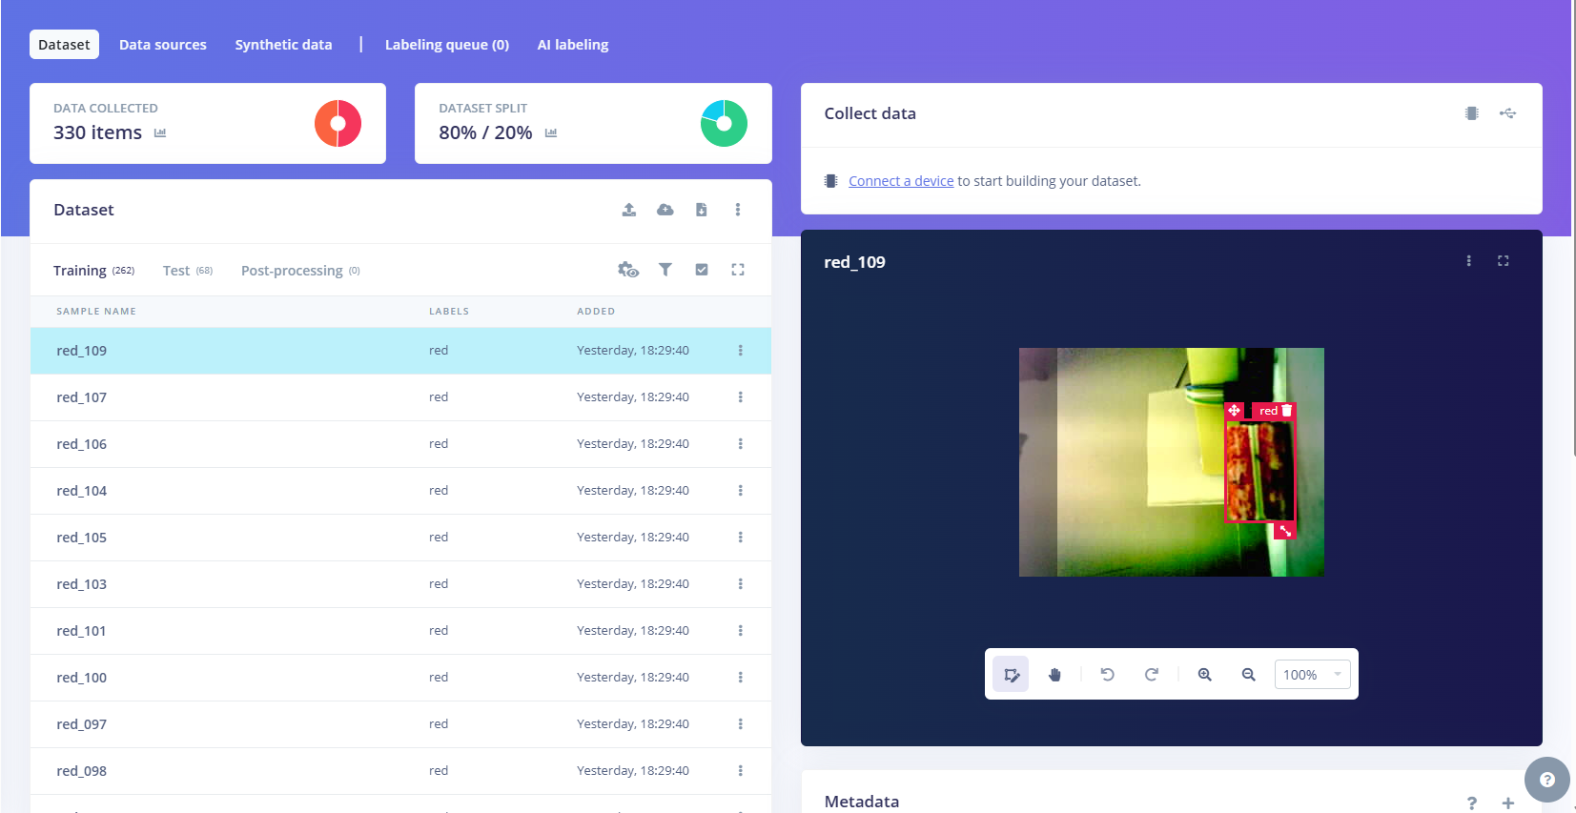

Machine Learning Result:
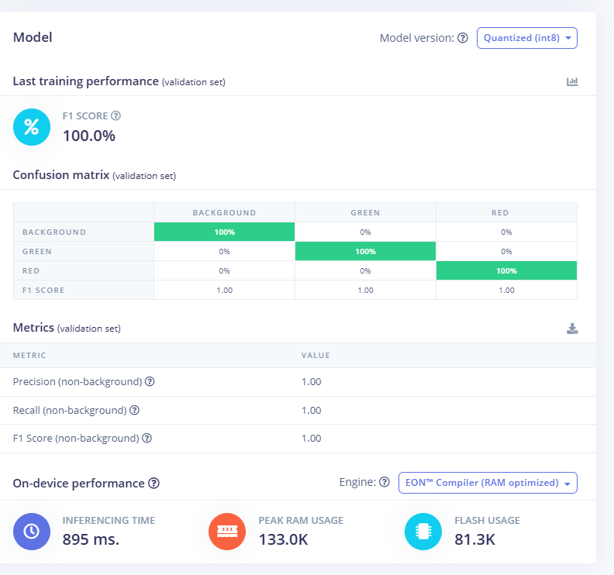

ESP32S3 Code

#include <Arduino.h>
#include "esp_camera.h"

// 1. Edge Impulse FOMO Inferencing Library
#include <ESP32S3-Sorter_inferencing.h>

// ==========================================
// 2. CAMERA PINOUT (ESP32-S3 CAM)
// ==========================================
#define PWDN_GPIO_NUM -1
#define RESET_GPIO_NUM -1
#define XCLK_GPIO_NUM 15
#define SIOD_GPIO_NUM 4
#define SIOC_GPIO_NUM 5

#define Y9_GPIO_NUM 16
#define Y8_GPIO_NUM 17
#define Y7_GPIO_NUM 18
#define Y6_GPIO_NUM 12
#define Y5_GPIO_NUM 10
#define Y4_GPIO_NUM 8
#define Y3_GPIO_NUM 9
#define Y2_GPIO_NUM 11

#define VSYNC_GPIO_NUM 6
#define HREF_GPIO_NUM 7
#define PCLK_GPIO_NUM 13

static camera_fb_t *fb = NULL;

// ==========================================
// 3. ZERO-COPY RGB565 SIGNAL CALLBACK
// ==========================================
static int raw_feature_get_data(size_t offset, size_t length, float *out_ptr) {
size_t pixel_ix = offset;
const uint8_t *buf = fb->buf;

for (size_t i = 0; i < length; i++) {
uint32_t x = (pixel_ix % EI_CLASSIFIER_INPUT_WIDTH);
uint32_t y = (pixel_ix / EI_CLASSIFIER_INPUT_WIDTH);

// Map 96x96 target coordinates to center 240x240 region
uint32_t src_x = 40 + ((x * 240) / EI_CLASSIFIER_INPUT_WIDTH);
uint32_t src_y = (y * 240) / EI_CLASSIFIER_INPUT_HEIGHT;
uint32_t byte_ix = (src_y * 320 + src_x) * 2;

// Unpack RGB565 to standard 24-bit RGB
uint16_t raw_pixel = (buf[byte_ix] << 8) | buf[byte_ix + 1];
uint8_t r = (raw_pixel >> 8) & 0xF8;
uint8_t g = (raw_pixel >> 3) & 0xFC;
uint8_t b = (raw_pixel << 3) & 0xF8;

out_ptr[i] = (float)(((uint32_t)r << 16) | ((uint32_t)g << 8) | b);
pixel_ix++;
}
return 0;
}

// ==========================================
// 4. DEDICATED INFERENCE TASK (32KB STACK)
// ==========================================
void fomoInferenceTask(void *pvParameters) {
signal_t features_signal;
features_signal.total_length = EI_CLASSIFIER_INPUT_WIDTH * EI_CLASSIFIER_INPUT_HEIGHT;
features_signal.get_data = &raw_feature_get_data;

while (true) {
fb = esp_camera_fb_get();
if (fb) {
uint32_t t_start = millis();

ei_impulse_result_t result = { 0 };
EI_IMPULSE_ERROR res = run_classifier(&features_signal, &result, false);

uint32_t infer_ms = millis() - t_start;
esp_camera_fb_return(fb);
fb = NULL;

if (res == EI_IMPULSE_OK) {
bool detected = false;

// Iterate through detected bounding boxes
for (uint32_t i = 0; i < result.bounding_boxes_count; i++) {
ei_impulse_result_bounding_box_t bb = result.bounding_boxes[i];

// 60% confidence filter
if (bb.value >= 0.60f) {
detected = true;
Serial.printf("[%3ums] DETECTED: >>> [ %s ] <<< (%.1f%%) at [x:%u, y:%u, w:%u, h:%u]\n",
infer_ms, bb.label, bb.value * 100.0f, bb.x, bb.y, bb.width, bb.height);
}
}

if (!detected) {
Serial.printf("[%3ums] Tray Status: >>> [ EMPTY ] <<<\n", infer_ms);
}
} else {
Serial.printf("[ERROR] Classifier failed with code: %d\n", res);
}
}
vTaskDelay(pdMS_TO_TICKS(40)); // Yield to prevent watchdog starvation
}
}

// ==========================================
// 5. SETUP
// ==========================================
void setup() {
Serial.begin(115200);
while (!Serial && millis() < 2000);
delay(500);

Serial.println("\n==============================================");
Serial.println(" ESP32-S3 FOMO OBJECT DETECTOR ONLINE ");
Serial.println("==============================================");

camera_config_t config;
config.ledc_channel = LEDC_CHANNEL_0;
config.ledc_timer = LEDC_TIMER_0;
config.pin_d0 = Y2_GPIO_NUM;
config.pin_d1 = Y3_GPIO_NUM;
config.pin_d2 = Y4_GPIO_NUM;
config.pin_d3 = Y5_GPIO_NUM;
config.pin_d4 = Y6_GPIO_NUM;
config.pin_d5 = Y7_GPIO_NUM;
config.pin_d6 = Y8_GPIO_NUM;
config.pin_d7 = Y9_GPIO_NUM;
config.pin_xclk = XCLK_GPIO_NUM;
config.pin_pclk = PCLK_GPIO_NUM;
config.pin_vsync = VSYNC_GPIO_NUM;
config.pin_href = HREF_GPIO_NUM;
config.pin_sccb_sda = SIOD_GPIO_NUM;
config.pin_sccb_scl = SIOC_GPIO_NUM;
config.pin_pwdn = PWDN_GPIO_NUM;
config.pin_reset = RESET_GPIO_NUM;
config.xclk_freq_hz = 20000000;
config.pixel_format = PIXFORMAT_RGB565; // Direct memory buffer
config.frame_size = FRAMESIZE_QVGA; // 320x240
config.fb_count = 2;
config.fb_location = CAMERA_FB_IN_PSRAM;
config.grab_mode = CAMERA_GRAB_LATEST;

if (esp_camera_init(&config) != ESP_OK) {
Serial.println("[FATAL] Camera hardware init failed!");
while (1);
}

// Lock sensor white balance and exposure
sensor_t *s = esp_camera_sensor_get();
s->set_brightness(s, 0);
s->set_contrast(s, 1);
s->set_saturation(s, 1);
s->set_whitebal(s, 1);
s->set_awb_gain(s, 1);
s->set_wb_mode(s, 2);
s->set_exposure_ctrl(s, 1);
s->set_aec2(s, 1);

Serial.println("[OK] Camera Initialized.");
Serial.println("[READY] Starting FOMO Task on Core 1...\n");

// Launch isolated FreeRTOS thread with 32KB stack in PSRAM
xTaskCreatePinnedToCore(
fomoInferenceTask,
"FOMO_Task",
32768,
NULL,
1,
NULL,
1
);
}

void loop() {
vTaskDelay(pdMS_TO_TICKS(1000));
}

Monkey Patching:

1. Replace Old Library in Arduino

- Close Arduino IDE.
- Go to Documents\Arduino\libraries\ in File Explorer and delete the old ESP32S3-Sorter_inferencing folder.
- Open Arduino IDE → Sketch → Include Library → Add .ZIP Library... → select the new .zip file.
- Compile and upload the sketch!

The reason you couldn't find it is because newer Edge Impulse versions dynamically calculate the arena and allocate it via ei_malloc().

The AllocateTensors() failed error happens because ei_malloc() is trying to allocate the 133 KB+ tensor arena inside the ESP32's internal SRAM (which only has ~100 KB contiguous free memory) instead of PSRAM.

Forcing Edge Impulse to allocate all tensor memory directly in PSRAM resolves this issue.

Step 1: Open the Porting File
- Open Windows File Explorer and navigate to:
- Documents\Arduino\libraries\ESP32S3-Sorter_inferencing\src\edge-impulse-sdk\porting\espressif\
- Open ei_classifier_porting.cpp in Notepad or VS Code.

ei_classifier_porting.cpp Code
/* The Clear BSD License
*
* Copyright (c) 2025 EdgeImpulse Inc.
* All rights reserved.
*
* Redistribution and use in source and binary forms, with or without
* modification, are permitted (subject to the limitations in the disclaimer
* below) provided that the following conditions are met:
*
* * Redistributions of source code must retain the above copyright notice,
* this list of conditions and the following disclaimer.
*
* * Redistributions in binary form must reproduce the above copyright
* notice, this list of conditions and the following disclaimer in the
* documentation and/or other materials provided with the distribution.
*
* * Neither the name of the copyright holder nor the names of its
* contributors may be used to endorse or promote products derived from this
* software without specific prior written permission.
*
* NO EXPRESS OR IMPLIED LICENSES TO ANY PARTY'S PATENT RIGHTS ARE GRANTED BY
* THIS LICENSE. THIS SOFTWARE IS PROVIDED BY THE COPYRIGHT HOLDERS AND
* CONTRIBUTORS "AS IS" AND ANY EXPRESS OR IMPLIED WARRANTIES, INCLUDING, BUT NOT
* LIMITED TO, THE IMPLIED WARRANTIES OF MERCHANTABILITY AND FITNESS FOR A
* PARTICULAR PURPOSE ARE DISCLAIMED. IN NO EVENT SHALL THE COPYRIGHT HOLDER OR
* CONTRIBUTORS BE LIABLE FOR ANY DIRECT, INDIRECT, INCIDENTAL, SPECIAL,
* EXEMPLARY, OR CONSEQUENTIAL DAMAGES (INCLUDING, BUT NOT LIMITED TO,
* PROCUREMENT OF SUBSTITUTE GOODS OR SERVICES; LOSS OF USE, DATA, OR PROFITS; OR
* BUSINESS INTERRUPTION) HOWEVER CAUSED AND ON ANY THEORY OF LIABILITY, WHETHER
* IN CONTRACT, STRICT LIABILITY, OR TORT (INCLUDING NEGLIGENCE OR OTHERWISE)
* ARISING IN ANY WAY OUT OF THE USE OF THIS SOFTWARE, EVEN IF ADVISED OF THE
* POSSIBILITY OF SUCH DAMAGE.
*/

#include "../ei_classifier_porting.h"
#if EI_PORTING_ESPRESSIF == 1

#include <stdarg.h>
#include <stdlib.h>
#include <stdio.h>
#include <cstring>
// Include FreeRTOS for delay
#include <freertos/FreeRTOS.h>
#include <freertos/task.h>

// for millis and micros
#include "esp_timer.h"
#include "esp_idf_version.h"

// memory handling
#include "esp_heap_caps.h"

#define EI_WEAK_FN __attribute__((weak))

EI_WEAK_FN EI_IMPULSE_ERROR ei_run_impulse_check_canceled() {
return EI_IMPULSE_OK;
}

EI_WEAK_FN EI_IMPULSE_ERROR ei_sleep(int32_t time_ms) {
vTaskDelay(time_ms / portTICK_RATE_MS);
return EI_IMPULSE_OK;
}

uint64_t ei_read_timer_ms() {
return esp_timer_get_time()/1000;
}

uint64_t ei_read_timer_us() {
return esp_timer_get_time();
}

void ei_putchar(char c)
{
/* Send char to serial output */
putchar(c);
}

/**
* Printf function uses vsnprintf and output using USB Serial
*/
__attribute__((weak)) void ei_printf(const char *format, ...) {
static char print_buf[1024] = { 0 };

va_list args;
va_start(args, format);
int r = vsnprintf(print_buf, sizeof(print_buf), format, args);
va_end(args);

if (r > 0) {
printf(print_buf);
}
}

__attribute__((weak)) void ei_printf_float(float f) {
ei_printf("%f", f);
}

// 16-byte aligned allocation targeting PSRAM first, falling back to internal RAM
__attribute__((weak)) void *ei_malloc(size_t size) {
void *ptr = NULL;

// 1. Try allocating in PSRAM with 16-byte alignment (Required for ESP32-S3 vector instructions)
ptr = heap_caps_aligned_alloc(16, size, MALLOC_CAP_SPIRAM | MALLOC_CAP_8BIT);

// 2. Fallback to internal RAM if PSRAM allocation fails
if (!ptr) {
ptr = heap_caps_aligned_alloc(16, size, MALLOC_CAP_INTERNAL | MALLOC_CAP_8BIT);
}

// 3. Final fallback
if (!ptr) {
ptr = malloc(size);
}

return ptr;
}

__attribute__((weak)) void *ei_calloc(size_t nitems, size_t size) {
size_t total_size = nitems * size;
void *p = ei_malloc(total_size);
if (p != NULL) {
memset(p, 0, total_size);
}
return p;
}

__attribute__((weak)) void ei_free(void *ptr) {
free(ptr);
}

#if defined(__cplusplus) && EI_C_LINKAGE == 1
extern "C"
#endif
__attribute__((weak)) void DebugLog(const char* s) {
ei_printf("%s", s);
}

#endif // EI_PORTING_ESPRESSIF == 1

In newer versions of the Edge Impulse library, the arena size is located in model_variables.h instead of model_metadata.h.
The TensorFlow Lite Micro runtime needs extra memory overhead for operator scratchpads and 16-byte tensor alignment. Expanding this value in model_variables.h will solve the AllocateTensors() failed error.

Step-by-Step Fix
1. Open model_variables.h
- Navigate to:
- Documents\Arduino\libraries\ESP32S3-Sorter_inferencing\src\model-parameters\
- Open model_variables.h in Notepad or VS Code.

model_variables.h code
/* The Clear BSD License
*
* Copyright (c) 2025 EdgeImpulse Inc.
* All rights reserved.
*
* Redistribution and use in source and binary forms, with or without
* modification, are permitted (subject to the limitations in the disclaimer
* below) provided that the following conditions are met:
*
* * Redistributions of source code must retain the above copyright notice,
* this list of conditions and the following disclaimer.
*
* * Redistributions in binary form must reproduce the above copyright
* notice, this list of conditions and the following disclaimer in the
* documentation and/or other materials provided with the distribution.
*
* * Neither the name of the copyright holder nor the names of its
* contributors may be used to endorse or promote products derived from this
* software without specific prior written permission.
*
* NO EXPRESS OR IMPLIED LICENSES TO ANY PARTY'S PATENT RIGHTS ARE GRANTED BY
* THIS LICENSE. THIS SOFTWARE IS PROVIDED BY THE COPYRIGHT HOLDERS AND
* CONTRIBUTORS "AS IS" AND ANY EXPRESS OR IMPLIED WARRANTIES, INCLUDING, BUT NOT
* LIMITED TO, THE IMPLIED WARRANTIES OF MERCHANTABILITY AND FITNESS FOR A
* PARTICULAR PURPOSE ARE DISCLAIMED. IN NO EVENT SHALL THE COPYRIGHT HOLDER OR
* CONTRIBUTORS BE LIABLE FOR ANY DIRECT, INDIRECT, INCIDENTAL, SPECIAL,
* EXEMPLARY, OR CONSEQUENTIAL DAMAGES (INCLUDING, BUT NOT LIMITED TO,
* PROCUREMENT OF SUBSTITUTE GOODS OR SERVICES; LOSS OF USE, DATA, OR PROFITS; OR
* BUSINESS INTERRUPTION) HOWEVER CAUSED AND ON ANY THEORY OF LIABILITY, WHETHER
* IN CONTRACT, STRICT LIABILITY, OR TORT (INCLUDING NEGLIGENCE OR OTHERWISE)
* ARISING IN ANY WAY OUT OF THE USE OF THIS SOFTWARE, EVEN IF ADVISED OF THE
* POSSIBILITY OF SUCH DAMAGE.
*/

#include "../ei_classifier_porting.h"
#if EI_PORTING_ESPRESSIF == 1

#include <stdarg.h>
#include <stdlib.h>
#include <stdio.h>
#include <cstring>
// Include FreeRTOS for delay
#include <freertos/FreeRTOS.h>
#include <freertos/task.h>

// for millis and micros
#include "esp_timer.h"
#include "esp_idf_version.h"

// memory handling
#include "esp_heap_caps.h"

#define EI_WEAK_FN __attribute__((weak))

EI_WEAK_FN EI_IMPULSE_ERROR ei_run_impulse_check_canceled() {
return EI_IMPULSE_OK;
}

EI_WEAK_FN EI_IMPULSE_ERROR ei_sleep(int32_t time_ms) {
vTaskDelay(time_ms / portTICK_RATE_MS);
return EI_IMPULSE_OK;
}

uint64_t ei_read_timer_ms() {
return esp_timer_get_time()/1000;
}

uint64_t ei_read_timer_us() {
return esp_timer_get_time();
}

void ei_putchar(char c)
{
/* Send char to serial output */
putchar(c);
}

/**
* Printf function uses vsnprintf and output using USB Serial
*/
__attribute__((weak)) void ei_printf(const char *format, ...) {
static char print_buf[1024] = { 0 };

va_list args;
va_start(args, format);
int r = vsnprintf(print_buf, sizeof(print_buf), format, args);
va_end(args);

if (r > 0) {
printf(print_buf);
}
}

__attribute__((weak)) void ei_printf_float(float f) {
ei_printf("%f", f);
}

// 16-byte aligned allocation targeting PSRAM first, falling back to internal RAM
__attribute__((weak)) void *ei_malloc(size_t size) {
void *ptr = NULL;

// 1. Try allocating in PSRAM with 16-byte alignment (Required for ESP32-S3 vector instructions)
ptr = heap_caps_aligned_alloc(16, size, MALLOC_CAP_SPIRAM | MALLOC_CAP_8BIT);

// 2. Fallback to internal RAM if PSRAM allocation fails
if (!ptr) {
ptr = heap_caps_aligned_alloc(16, size, MALLOC_CAP_INTERNAL | MALLOC_CAP_8BIT);
}

// 3. Final fallback
if (!ptr) {
ptr = malloc(size);
}

return ptr;
}

__attribute__((weak)) void *ei_calloc(size_t nitems, size_t size) {
size_t total_size = nitems * size;
void *p = ei_malloc(total_size);
if (p != NULL) {
memset(p, 0, total_size);
}
return p;
}

__attribute__((weak)) void ei_free(void *ptr) {
free(ptr);
}

#if defined(__cplusplus) && EI_C_LINKAGE == 1
extern "C"
#endif
__attribute__((weak)) void DebugLog(const char* s) {
ei_printf("%s", s);
}

#endif // EI_PORTING_ESPRESSIF == 1

Full Code

ESP32S3 Code

#include <Arduino.h>
#include <WiFi.h>
#include "esp_http_server.h"
#include "esp_camera.h"

// 1. Edge Impulse FOMO Model Header
#include <ESP32S3-Sorter_inferencing.h>

// ==========================================
// 2. WI-FI & UART PINOUT
// ==========================================
const char *ssid = "Zarif";
const char *password = "password12";

#define NANO_RX_PIN 1 // ESP32 RX (from Nano Pin D7)
#define NANO_TX_PIN 2 // ESP32 TX (to Nano Pin D6)

HardwareSerial NanoSerial(1);
httpd_handle_t server = NULL;

// ==========================================
// 3. CAMERA PINOUT (ESP32-S3 CAM)
// ==========================================
#define PWDN_GPIO_NUM -1
#define RESET_GPIO_NUM -1
#define XCLK_GPIO_NUM 15
#define SIOD_GPIO_NUM 4
#define SIOC_GPIO_NUM 5

#define Y9_GPIO_NUM 16
#define Y8_GPIO_NUM 17
#define Y7_GPIO_NUM 18
#define Y6_GPIO_NUM 12
#define Y5_GPIO_NUM 10
#define Y4_GPIO_NUM 8
#define Y3_GPIO_NUM 9
#define Y2_GPIO_NUM 11

#define VSYNC_GPIO_NUM 6
#define HREF_GPIO_NUM 7
#define PCLK_GPIO_NUM 13

static camera_fb_t *fb = NULL;

// ==========================================
// 4. TELEMETRY & SYSTEM REGISTERS
// ==========================================
enum SystemState {
STATE_IDLE = 0,
STATE_SAMPLING = 1,
STATE_SORTING = 2,
STATE_FAULT = 3,
STATE_FULL_GREEN = 4,
STATE_FULL_RED = 5
};

volatile SystemState currentState = STATE_IDLE;
volatile unsigned long samplingStartTime = 0;
const unsigned long SAMPLING_DURATION_MS = 5000;

volatile int votesRed = 0;
volatile int votesGreen = 0;
volatile int votesEmpty = 0;
volatile int totalInferences = 0;
volatile float remainingSeconds = 0.0;

volatile float distRedCM = 25.0; // Left Bin (CH 0)
volatile float distGreenCM = 25.0; // Right Bin (CH 12)

String latestVerdict = "STANDBY";
String statusText = "Awaiting object in chute...";
String lastLogMsg = "Telemetry link established.";

// ==========================================
// 5. ZERO-COPY RGB565 SIGNAL CALLBACK
// ==========================================
static int raw_feature_get_data(size_t offset, size_t length, float *out_ptr) {
size_t pixel_ix = offset;
const uint8_t *buf = fb->buf;

for (size_t i = 0; i < length; i++) {
uint32_t x = (pixel_ix % EI_CLASSIFIER_INPUT_WIDTH);
uint32_t y = (pixel_ix / EI_CLASSIFIER_INPUT_WIDTH);

uint32_t src_x = 40 + ((x * 240) / EI_CLASSIFIER_INPUT_WIDTH);
uint32_t src_y = (y * 240) / EI_CLASSIFIER_INPUT_HEIGHT;
uint32_t byte_ix = (src_y * 320 + src_x) * 2;

uint16_t raw_pixel = (buf[byte_ix] << 8) | buf[byte_ix + 1];
uint8_t r = (raw_pixel >> 8) & 0xF8;
uint8_t g = (raw_pixel >> 3) & 0xFC;
uint8_t b = (raw_pixel << 3) & 0xF8;

out_ptr[i] = (float)(((uint32_t)r << 16) | ((uint32_t)g << 8) | b);
pixel_ix++;
}
return 0;
}

void startSamplingProcess() {
votesRed = 0;
votesGreen = 0;
votesEmpty = 0;
totalInferences = 0;
latestVerdict = "SAMPLING...";
statusText = "Analyzing Object in Chute...";
lastLogMsg = "⚡ IR Trigger -> 5s Vision Sampling Started.";
samplingStartTime = millis();
currentState = STATE_SAMPLING;
}

// ==========================================
// 6. FREERTOS INFERENCE & TELEMETRY THREAD
// ==========================================
void fomoInferenceTask(void *pvParameters) {
signal_t features_signal;
features_signal.total_length = EI_CLASSIFIER_INPUT_WIDTH * EI_CLASSIFIER_INPUT_HEIGHT;
features_signal.get_data = &raw_feature_get_data;

while (true) {
while (NanoSerial.available() > 0) {
String line = NanoSerial.readStringUntil('\n');
line.trim();

if (line.startsWith("U:")) {
int commaIdx = line.indexOf(',');
if (commaIdx > 2) {
distRedCM = line.substring(2, commaIdx).toFloat();
distGreenCM = line.substring(commaIdx + 1).toFloat();
}
}
else if (line == "D") {
startSamplingProcess();
}
else if (line == "A") {
currentState = STATE_FAULT;
remainingSeconds = 0.0;
latestVerdict = "FAULT: REMOVED";
statusText = "Object pulled away mid-scan!";
lastLogMsg = "⚠️ FAULT: Target removed prematurely. Aborted.";
}
else if (line == "F1") {
currentState = STATE_FULL_GREEN;
remainingSeconds = 0.0;
latestVerdict = "GREEN BIN FULL";
statusText = "Right container (CH 12) <= 3.0 cm!";
lastLogMsg = "🛑 ALERT: Green Bin (Right / CH 12) full.";
}
else if (line == "F2") {
currentState = STATE_FULL_RED;
remainingSeconds = 0.0;
latestVerdict = "RED BIN FULL";
statusText = "Left container (CH 0) <= 3.0 cm!";
lastLogMsg = "🛑 ALERT: Red Bin (Left / CH 0) full.";
}
else if (line == "K") {
currentState = STATE_IDLE;
latestVerdict = "STANDBY";
statusText = "Sort complete. Ready for next item.";
lastLogMsg = "✅ Arm returned to Home. Standby.";
}
}

if (currentState == STATE_SAMPLING) {
unsigned long elapsed = millis() - samplingStartTime;

if (elapsed < SAMPLING_DURATION_MS) {
remainingSeconds = (SAMPLING_DURATION_MS - elapsed) / 1000.0;

fb = esp_camera_fb_get();
if (fb) {
ei_impulse_result_t result = { 0 };
EI_IMPULSE_ERROR res = run_classifier(&features_signal, &result, false);
esp_camera_fb_return(fb);
fb = NULL;

if (res == EI_IMPULSE_OK) {
bool foundItem = false;
for (uint32_t i = 0; i < result.bounding_boxes_count; i++) {
ei_impulse_result_bounding_box_t bb = result.bounding_boxes[i];
if (bb.value >= 0.60f) {
foundItem = true;
if (strcmp(bb.label, "red") == 0) votesRed++;
if (strcmp(bb.label, "green") == 0) votesGreen++;
}
}
if (!foundItem) votesEmpty++;
totalInferences++;
}
}
} else {
remainingSeconds = 0.0;
currentState = STATE_SORTING;

char verdictCode = 'E';
if (votesRed > votesGreen && votesRed > votesEmpty) {
latestVerdict = "RECYCLABLE (RED)";
statusText = "Solid RED Confirmed";
verdictCode = 'R';
} else if (votesGreen > votesRed && votesGreen > votesEmpty) {
latestVerdict = "BIODEGRADABLE (GREEN)";
statusText = "Solid GREEN Confirmed";
verdictCode = 'G';
} else {
latestVerdict = "EMPTY / UNCERTAIN";
statusText = "No dominant class confirmed";
verdictCode = 'E';
}

NanoSerial.println(verdictCode); // Transmit with newline
NanoSerial.flush();
lastLogMsg = "✅ Scan Complete. Sent verdict '" + String(verdictCode) + "' to Nano.";
}
}

vTaskDelay(pdMS_TO_TICKS(20));
}
}

// ==========================================
// 7. RESPONSIVE DASHBOARD
// ==========================================
const char INDEX_HTML[] PROGMEM = R"rawliteral(
<!DOCTYPE html>
<html lang="en">
<head>
<meta charset="UTF-8">
<meta name="viewport" content="width=device-width, initial-scale=1, maximum-scale=1, user-scalable=no">
<title>SmartSort Mission Control</title>
<style>
:root {
--bg: #07090e;
--card-bg: rgba(18, 24, 38, 0.7);
--card-border: rgba(255, 255, 255, 0.08);
--cyan: #00f2fe;
--emerald: #10b981;
--rose: #f43f5e;
--amber: #f59e0b;
--text: #f8fafc;
--text-muted: #64748b;
}

* { box-sizing: border-box; margin: 0; padding: 0; -webkit-tap-highlight-color: transparent; }

body {
font-family: -apple-system, BlinkMacSystemFont, "Segoe UI", Roboto, sans-serif;
background: var(--bg);
background-image: radial-gradient(circle at top right, rgba(0, 242, 254, 0.05), transparent 40%),
radial-gradient(circle at bottom left, rgba(244, 63, 94, 0.05), transparent 40%);
color: var(--text);
min-height: 100vh;
padding: 16px;
display: flex;
justify-content: center;
}

.container { width: 100%; max-width: 440px; }

.brand { display: flex; justify-content: space-between; align-items: center; margin-bottom: 16px; padding: 0 4px; }
.brand-title { font-size: 18px; font-weight: 800; letter-spacing: -0.5px; }
.brand-title span { color: var(--cyan); }
.status-pill {
font-size: 11px;
font-weight: 700;
padding: 4px 10px;
border-radius: 20px;
background: rgba(16, 185, 129, 0.15);
color: var(--emerald);
border: 1px solid rgba(16, 185, 129, 0.3);
display: flex;
align-items: center;
gap: 5px;
}
.status-dot { width: 6px; height: 6px; background: var(--emerald); border-radius: 50%; box-shadow: 0 0 8px var(--emerald); }

.card {
background: var(--card-bg);
backdrop-filter: blur(16px);
-webkit-backdrop-filter: blur(16px);
border: 1px solid var(--card-border);
border-radius: 18px;
padding: 16px;
margin-bottom: 14px;
box-shadow: 0 10px 30px rgba(0, 0, 0, 0.4);
}

.hero-verdict {
padding: 22px 16px;
text-align: center;
border-radius: 16px;
transition: all 0.4s cubic-bezier(0.4, 0, 0.2, 1);
}
.hero-title { font-size: 11px; font-weight: 700; text-transform: uppercase; letter-spacing: 1.5px; opacity: 0.7; }
.hero-val { font-size: 24px; font-weight: 900; margin: 6px 0; letter-spacing: -0.5px; }
.hero-sub { font-size: 13px; opacity: 0.85; }

.state-idle { background: rgba(30, 41, 59, 0.5); border: 1px dashed rgba(255, 255, 255, 0.15); color: #94a3b8; }
.state-sampling { background: linear-gradient(135deg, rgba(79, 70, 229, 0.3), rgba(124, 58, 237, 0.3)); border: 1px solid #818cf8; color: #c7d2fe; box-shadow: 0 0 25px rgba(99, 102, 241, 0.3); }
.state-red { background: linear-gradient(135deg, rgba(185, 28, 28, 0.4), rgba(127, 29, 29, 0.4)); border: 1px solid var(--rose); color: #fecdd3; box-shadow: 0 0 25px rgba(244, 63, 94, 0.3); }
.state-green { background: linear-gradient(135deg, rgba(6, 95, 70, 0.4), rgba(4, 120, 87, 0.4)); border: 1px solid var(--emerald); color: #a7f3d0; box-shadow: 0 0 25px rgba(16, 185, 129, 0.3); }
.state-fault { background: linear-gradient(135deg, rgba(180, 83, 9, 0.4), rgba(146, 64, 14, 0.4)); border: 1px solid var(--amber); color: #fde68a; box-shadow: 0 0 25px rgba(245, 158, 11, 0.3); animation: pulse 0.8s infinite alternate; }
.state-full { background: linear-gradient(135deg, rgba(159, 18, 57, 0.5), rgba(136, 19, 55, 0.5)); border: 1px solid var(--rose); color: #ffe4e6; box-shadow: 0 0 30px rgba(244, 63, 94, 0.4); animation: pulse 0.6s infinite alternate; }

@keyframes pulse { from { opacity: 0.75; transform: scale(0.99); } to { opacity: 1; transform: scale(1); } }

.timer-track { width: 100%; height: 6px; background: rgba(255, 255, 255, 0.08); border-radius: 3px; overflow: hidden; margin-top: 12px; }
.timer-bar { width: 0%; height: 100%; background: linear-gradient(90deg, var(--cyan), #818cf8); transition: width 0.1s linear; }

.gauge-row { margin: 12px 0 6px 0; }
.gauge-meta { display: flex; justify-content: space-between; font-size: 13px; font-weight: 600; margin-bottom: 6px; }
.gauge-bg { width: 100%; height: 12px; background: rgba(255, 255, 255, 0.06); border-radius: 6px; overflow: hidden; position: relative; }
.gauge-fill { height: 100%; border-radius: 6px; transition: width 0.3s cubic-bezier(0.4, 0, 0.2, 1); }
.gauge-green { background: linear-gradient(90deg, #059669, var(--emerald)); }
.gauge-red { background: linear-gradient(90deg, #dc2626, var(--rose)); }

.console-header { display: flex; justify-content: space-between; font-size: 11px; font-weight: 700; color: var(--text-muted); text-transform: uppercase; letter-spacing: 1px; margin-bottom: 8px; }
.console-box {
background: #04060a;
border: 1px solid rgba(255, 255, 255, 0.05);
border-radius: 10px;
padding: 10px;
font-family: ui-monospace, "SF Mono", Menlo, Consolas, monospace;
font-size: 11px;
color: var(--cyan);
height: 95px;
overflow-y: auto;
line-height: 1.5;
}

.modal-overlay {
display: none;
position: fixed;
top: 0; left: 0; width: 100%; height: 100%;
background: rgba(4, 6, 10, 0.85);
backdrop-filter: blur(8px);
z-index: 999;
align-items: center;
justify-content: center;
padding: 20px;
}
.modal-card {
background: #151d2c;
border: 2px solid var(--rose);
border-radius: 20px;
padding: 24px 20px;
width: 100%;
max-width: 380px;
text-align: center;
box-shadow: 0 20px 40px rgba(0, 0, 0, 0.6), 0 0 30px rgba(244, 63, 94, 0.3);
animation: modalPop 0.3s cubic-bezier(0.175, 0.885, 0.32, 1.275);
}
@keyframes modalPop { from { transform: scale(0.85); opacity: 0; } to { transform: scale(1); opacity: 1; } }

.modal-card h3 { font-size: 20px; font-weight: 800; color: #fff; margin-bottom: 8px; }
.modal-card p { font-size: 13px; color: #94a3b8; line-height: 1.5; margin-bottom: 20px; }

.btn-stack { display: flex; flex-direction: column; gap: 10px; }
.btn {
width: 100%;
padding: 14px;
border: none;
border-radius: 12px;
font-size: 14px;
font-weight: 700;
cursor: pointer;
display: flex;
align-items: center;
justify-content: center;
gap: 8px;
}
.btn:active { transform: scale(0.98); }
.btn-manual { background: rgba(255, 255, 255, 0.1); color: #fff; border: 1px solid rgba(255, 255, 255, 0.2); }
.btn-auto-dump { background: linear-gradient(135deg, var(--rose), #be123c); color: #fff; box-shadow: 0 4px 15px rgba(244, 63, 94, 0.4); }
</style>
</head>
<body onclick="initAudio()">
<div class="container">

<div class="brand">
<div class="brand-title">SMART<span>SORT</span></div>
<div class="status-pill">
<div class="status-dot"></div>
<span>AUTONOMOUS</span>
</div>
</div>

<div id="verdictCard" class="card hero-verdict state-idle">
<div class="hero-title">NEURAL VISION STATUS</div>
<div id="verdictText" class="hero-val">STANDBY</div>
<div id="subStatus" class="hero-sub">Awaiting object in chute...</div>

<div class="timer-track">
<div id="timerBar" class="timer-bar"></div>
</div>
</div>

<div class="card">
<div style="font-size: 13px; font-weight: 800; letter-spacing: -0.3px; margin-bottom: 4px;">BIN LEVEL TELEMETRY</div>
<div style="font-size: 11px; color: var(--text-muted); margin-bottom: 12px;">Threshold: Full at &lt; 3.0 cm (5s verify)</div>

<!-- Red Bin (Left / CH 0) -->
<div class="gauge-row">
<div class="gauge-meta">
<span style="color: var(--rose);">🔴 Recyclable (Left / CH 0)</span>
<strong id="distRedText">25.0 cm</strong>
</div>
<div class="gauge-bg">
<div id="fillRed" class="gauge-fill gauge-red" style="width: 0%;"></div>
</div>
</div>

<!-- Green Bin (Right / CH 12) -->
<div class="gauge-row">
<div class="gauge-meta">
<span style="color: var(--emerald);">🟢 Biodegradable (Right / CH 12)</span>
<strong id="distGreenText">25.0 cm</strong>
</div>
<div class="gauge-bg">
<div id="fillGreen" class="gauge-fill gauge-green" style="width: 0%;"></div>
</div>
</div>
</div>

<div class="card">
<div class="console-header">
<span>Hardware Event Bus</span>
<span style="color: var(--cyan);">9600 BAUD</span>
</div>
<div class="console-box" id="termLog">
&gt; System initialized. Awaiting sensor events...
</div>
</div>

</div>

<div class="modal-overlay" id="alertModal">
<div class="modal-card">
<div style="font-size: 36px; margin-bottom: 8px;">🛑</div>
<h3 id="modalTitle">BIN FULL ALERT</h3>
<p id="modalDesc">Container capacity threshold exceeded (&lt; 3.0 cm for 5 consecutive seconds). Choose clearance pathway:</p>

<div class="btn-stack">
<button class="btn btn-auto-dump" id="btnAutoDump" onclick="resolveSystemDump()">
<span>⚙️</span> <span id="autoDumpLabel">Let System Handle It (Auto-Dump)</span>
</button>
<button class="btn btn-manual" onclick="resolveManualEmpty()">
<span>✋</span> <span>I Emptied It (Manual Reset)</span>
</button>
</div>
</div>
</div>

<script>
let audioCtx = null;
let activeFullBin = 0;

function initAudio() {
if (!audioCtx) {
audioCtx = new (window.AudioContext || window.webkitAudioContext)();
}
}

function playAlarm(isFault) {
if (!audioCtx) return;
try {
const osc = audioCtx.createOscillator();
const gain = audioCtx.createGain();
osc.type = isFault ? 'sawtooth' : 'square';
osc.frequency.setValueAtTime(isFault ? 330 : 880, audioCtx.currentTime);
if (!isFault) {
osc.frequency.exponentialRampToValueAtTime(660, audioCtx.currentTime + 0.3);
}
gain.gain.setValueAtTime(0.25, audioCtx.currentTime);
gain.gain.exponentialRampToValueAtTime(0.01, audioCtx.currentTime + 0.4);
osc.connect(gain);
gain.connect(audioCtx.destination);
osc.start();
osc.stop(audioCtx.currentTime + 0.4);
} catch(e){}
}

function triggerHaptics(pattern) {
if ("vibrate" in navigator) {
navigator.vibrate(pattern);
}
}

let lastState = 0;

function pollStatus() {
fetch('/status')
.then(res => res.json())
.then(data => {
document.getElementById('distRedText').innerText = data.dL.toFixed(1) + ' cm';
document.getElementById('distGreenText').innerText = data.dR.toFixed(1) + ' cm';

const pctRed = Math.max(0, Math.min(100, ((25.0 - data.dL) / 22.0) * 100));
const pctGreen = Math.max(0, Math.min(100, ((25.0 - data.dR) / 22.0) * 100));
document.getElementById('fillRed').style.width = pctRed + '%';
document.getElementById('fillGreen').style.width = pctGreen + '%';

document.getElementById('verdictText').innerText = data.vrd;
document.getElementById('subStatus').innerText = data.sub;

const pctTimer = ((5.0 - data.sec) / 5.0) * 100;
document.getElementById('timerBar').style.width = (data.st === 1 ? pctTimer : (data.st === 2 ? 100 : 0)) + '%';

const card = document.getElementById('verdictCard');
card.className = "card hero-verdict " +
(data.st === 0 ? "state-idle" :
(data.st === 1 ? "state-sampling" :
(data.st === 3 ? "state-fault" :
(data.st === 4 || data.st === 5 ? "state-full" :
(data.vrd.includes("RED") ? "state-red" : "state-green")))));

if (data.st !== lastState) {
if (data.st === 3) {
playAlarm(true);
triggerHaptics([150, 80, 150]);
}
else if (data.st === 4) {
activeFullBin = 1;
document.getElementById('modalTitle').innerText = "🟢 GREEN BIN FULL";
document.getElementById('modalDesc').innerText = "Biodegradable container (Right / CH 12) measured <= 3.0 cm for 5.0s. Select clearance method:";
document.getElementById('autoDumpLabel').innerText = "Auto-Dump Green Chute (Latch 2 / CH 12)";
document.getElementById('alertModal').style.display = 'flex';
playAlarm(false);
triggerHaptics([300, 100, 300, 100, 500]);
}
else if (data.st === 5) {
activeFullBin = 2;
document.getElementById('modalTitle').innerText = "🔴 RED BIN FULL";
document.getElementById('modalDesc').innerText = "Recyclable container (Left / CH 0) measured <= 3.0 cm for 5.0s. Select clearance method:";
document.getElementById('autoDumpLabel').innerText = "Auto-Dump Red Chute (Latch 1 / CH 0)";
document.getElementById('alertModal').style.display = 'flex';
playAlarm(false);
triggerHaptics([300, 100, 300, 100, 500]);
}
lastState = data.st;
}

if (data.log && data.log.length > 0) {
const term = document.getElementById('termLog');
term.innerHTML = "&gt; " + data.log + "<br>" + term.innerHTML;
}
})
.catch(err => console.error(err));
}

function resolveManualEmpty() {
document.getElementById('alertModal').style.display = 'none';
fetch('/reset_state');
}

function resolveSystemDump() {
document.getElementById('alertModal').style.display = 'none';
fetch('/dump?bin=' + activeFullBin);
}

setInterval(pollStatus, 250);
</script>
</body>
</html>
)rawliteral";

// ==========================================
// 8. HTTP ROUTING HANDLERS
// ==========================================
esp_err_t index_handler(httpd_req_t *req) {
httpd_resp_set_type(req, "text/html");
return httpd_resp_send(req, INDEX_HTML, HTTPD_RESP_USE_STRLEN);
}

esp_err_t status_handler(httpd_req_t *req) {
char json[340];
snprintf(json, sizeof(json),
"{\"st\":%d,\"vrd\":\"%s\",\"sub\":\"%s\",\"sec\":%.2f,\"dL\":%.1f,\"dR\":%.1f,\"log\":\"%s\"}",
(int)currentState, latestVerdict.c_str(), statusText.c_str(), remainingSeconds, distRedCM, distGreenCM, lastLogMsg.c_str());

lastLogMsg = "";
httpd_resp_set_type(req, "application/json");
httpd_resp_set_hdr(req, "Access-Control-Allow-Origin", "*");
return httpd_resp_send(req, json, HTTPD_RESP_USE_STRLEN);
}

esp_err_t dump_handler(httpd_req_t *req) {
char param[16];
if (httpd_req_get_url_query_str(req, param, sizeof(param)) == ESP_OK) {
char val[4];
if (httpd_query_key_value(param, "bin", val, sizeof(val)) == ESP_OK) {
if (val[0] == '1') {
NanoSerial.println("1");
lastLogMsg = "⚙️ Auto-Dumping Green Bin (CH 12)...";
} else if (val[0] == '2') {
NanoSerial.println("2");
lastLogMsg = "⚙️ Auto-Dumping Red Bin (CH 0)...";
}
NanoSerial.flush();
}
}
currentState = STATE_IDLE;
latestVerdict = "STANDBY";
statusText = "Dump routine executed. Ready.";
return httpd_resp_send(req, "OK", HTTPD_RESP_USE_STRLEN);
}

esp_err_t reset_state_handler(httpd_req_t *req) {
NanoSerial.println("C");
NanoSerial.flush();
currentState = STATE_IDLE;
latestVerdict = "STANDBY";
statusText = "System manually reset.";
lastLogMsg = "✋ Manual clearance confirmed by user.";
return httpd_resp_send(req, "OK", HTTPD_RESP_USE_STRLEN);
}

void startWebServer() {
httpd_config_t config = HTTPD_DEFAULT_CONFIG();
config.server_port = 80;

httpd_uri_t index_uri = { .uri = "/", .method = HTTP_GET, .handler = index_handler, .user_ctx = NULL };
httpd_uri_t status_uri = { .uri = "/status", .method = HTTP_GET, .handler = status_handler, .user_ctx = NULL };
httpd_uri_t dump_uri = { .uri = "/dump", .method = HTTP_GET, .handler = dump_handler, .user_ctx = NULL };
httpd_uri_t reset_uri = { .uri = "/reset_state", .method = HTTP_GET, .handler = reset_state_handler, .user_ctx = NULL };

if (httpd_start(&server, &config) == ESP_OK) {
httpd_register_uri_handler(server, &index_uri);
httpd_register_uri_handler(server, &status_uri);
httpd_register_uri_handler(server, &dump_uri);
httpd_register_uri_handler(server, &reset_uri);
}
}

// ==========================================
// 9. SETUP
// ==========================================
void setup() {
Serial.begin(115200);
while (!Serial && millis() < 2000);
delay(500);

NanoSerial.begin(9600, SERIAL_8N1, NANO_RX_PIN, NANO_TX_PIN);

camera_config_t config;
config.ledc_channel = LEDC_CHANNEL_0;
config.ledc_timer = LEDC_TIMER_0;
config.pin_d0 = Y2_GPIO_NUM;
config.pin_d1 = Y3_GPIO_NUM;
config.pin_d2 = Y4_GPIO_NUM;
config.pin_d3 = Y5_GPIO_NUM;
config.pin_d4 = Y6_GPIO_NUM;
config.pin_d5 = Y7_GPIO_NUM;
config.pin_d6 = Y8_GPIO_NUM;
config.pin_d7 = Y9_GPIO_NUM;
config.pin_xclk = XCLK_GPIO_NUM;
config.pin_pclk = PCLK_GPIO_NUM;
config.pin_vsync = VSYNC_GPIO_NUM;
config.pin_href = HREF_GPIO_NUM;
config.pin_sccb_sda = SIOD_GPIO_NUM;
config.pin_sccb_scl = SIOC_GPIO_NUM;
config.pin_pwdn = PWDN_GPIO_NUM;
config.pin_reset = RESET_GPIO_NUM;
config.xclk_freq_hz = 20000000;
config.pixel_format = PIXFORMAT_RGB565;
config.frame_size = FRAMESIZE_QVGA;
config.fb_count = 2;
config.fb_location = CAMERA_FB_IN_PSRAM;
config.grab_mode = CAMERA_GRAB_LATEST;

if (esp_camera_init(&config) != ESP_OK) {
Serial.println("[FATAL] Camera init failed!");
while (1);
}

sensor_t *s = esp_camera_sensor_get();
s->set_brightness(s, 0);
s->set_contrast(s, 1);
s->set_saturation(s, 1);
s->set_whitebal(s, 1);
s->set_awb_gain(s, 1);
s->set_wb_mode(s, 2);
s->set_exposure_ctrl(s, 1);
s->set_aec2(s, 1);

WiFi.mode(WIFI_STA);
WiFi.begin(ssid, password);
int attempts = 0;
while (WiFi.status() != WL_CONNECTED && attempts < 40) {
delay(500);
attempts++;
}
WiFi.setSleep(false);

if (WiFi.status() == WL_CONNECTED) {
Serial.print("📱 Open on phone: http://");
Serial.println(WiFi.localIP());
startWebServer();
}

xTaskCreatePinnedToCore(
fomoInferenceTask,
"FOMO_Task",
32768,
NULL,
1,
NULL,
1
);
}

void loop() {
vTaskDelay(pdMS_TO_TICKS(1000));
}

Arduino Code
#include <Wire.h>
#include <Adafruit_PWMServoDriver.h>
#include <SoftwareSerial.h>

// ==========================================
// 1. PIN CONFIGURATION & DRIVERS
// ==========================================
// SoftwareSerial: RX = Pin 6 (from ESP32 TX), TX = Pin 7 (to ESP32 RX)
SoftwareSerial espSerial(6, 7);
Adafruit_PWMServoDriver pwm = Adafruit_PWMServoDriver(0x40);

// 5-Array IR Sensor (Active-HIGH: 1 = Detected)
const int irPins[5] = {8, 9, 10, 11, 12};

// Dual Ultrasonic Sensors
const int LEFT_TRIG_PIN = 2; // Left Bin: RED / Recyclable
const int LEFT_ECHO_PIN = 3;
const int RIGHT_TRIG_PIN = 4; // Right Bin: GREEN / Biodegradable
const int RIGHT_ECHO_PIN = 5;

// Threshold for full bin (including blind spot: 0.0cm to 3.0cm)
const float BIN_FULL_THRESHOLD_CM = 3.0;
const unsigned long FULL_VERIFY_DURATION_MS = 5000; // 5-second sampling verification

// ==========================================
// 2. SERVO & JOINT CONFIGURATION
// ==========================================
struct Joint {
uint8_t channel;
char cmdLetter;
const char* name;
int minTicks;
int maxTicks;
int currentAngle;
int homeAngle;
int stepDelay;
bool isRelaxed;
};

Joint joints[] = {
// ch, cmd, name, minT, maxT, initA, homeA, stepDelay, isRelaxed
{ 4, 'b', "Base", 150, 550, 70, 70, 15, false }, // MG996R (CH 4)
{ 10, 'a', "Arm", 150, 550, 170, 170, 15, false }, // MG996R (CH 10)
{ 11, 'e', "Elbow", 150, 500, 45, 45, 15, false }, // SG90/MG996R (CH 11)
{ 1, 'g', "Gripper", 150, 500, 70, 70, 8, false }, // Gripper (CH 1)
{ 0, 'x', "SG90 Red Latch (L)", 140, 470, 50, 50, 6, false }, // CH 0: Left / Red (Home 50, Open 140)
{ 12, 'y', "SG90 Green Latch (R)", 140, 470, 145, 145, 6, false } // CH 12: Right / Green (Home 145, Open 20)
};

const int NUM_JOINTS = sizeof(joints) / sizeof(joints[0]);

const int PICK_ELBOW = 65;
const int PICK_ARM = 132;
const int GRIP_CLOSE = 180;
const int GRIP_OPEN = 70;
const int DROP_BASE_G = 10; // Green / Right Bin Base Angle
const int DROP_BASE_R = 110; // Red / Left Bin Base Angle

const int LATCH_RED_HOME = 50; // CH 0
const int LATCH_RED_OPEN = 140;
const int LATCH_GREEN_HOME = 145; // CH 12
const int LATCH_GREEN_OPEN = 20;

// ==========================================
// 3. STATE MACHINE & TIMING
// ==========================================
enum SorterState {
STATE_IDLE,
STATE_WAITING_VERDICT,
STATE_COOLDOWN
};

SorterState currentState = STATE_IDLE;
unsigned long triggerStartTime = 0;
unsigned long lastTelemetryTime = 0;
const unsigned long TIMEOUT_MS = 10000;

unsigned long redFullStartTime = 0;
bool redFullTimerActive = false;
unsigned long greenFullStartTime = 0;
bool greenFullTimerActive = false;

// Forward declarations
void setServoAngle(Joint &j, int angle);
void moveJoint(Joint &j, int targetAngle);
void goHomeAll();
bool isObjectPresent();
float readDistanceCM(int trigPin, int echoPin);
bool verifyBinFullSampling(const char* binName, int trigPin, int echoPin);
bool executePickAndPlace(const char* label, int dropBaseAngle);
void dumpBinLatch(int binIndex);

void setup() {
Serial.begin(115200);
espSerial.begin(9600);
Wire.begin();

#if defined(WIRE_HAS_TIMEOUT)
Wire.setWireTimeout(3000, true);
#endif

for (int i = 0; i < 5; i++) {
pinMode(irPins[i], INPUT);
}

pinMode(LEFT_TRIG_PIN, OUTPUT);
pinMode(LEFT_ECHO_PIN, INPUT);
pinMode(RIGHT_TRIG_PIN, OUTPUT);
pinMode(RIGHT_ECHO_PIN, INPUT);

pwm.begin();
pwm.setPWMFreq(50);
delay(100);

for (int i = 0; i < NUM_JOINTS; i++) {
setServoAngle(joints[i], joints[i].homeAngle);
joints[i].currentAngle = joints[i].homeAngle;
joints[i].isRelaxed = false;
}

Serial.println(F("\n======================================================="));
Serial.println(F(">>> ARDUINO NANO: AUTONOMOUS SORTING ENGINE READY <<<"));
Serial.println(F(" Left Bin (CH 0 / D2,D3) = RED / RECYCLABLE "));
Serial.println(F(" Right Bin (CH 12 / D4,D5) = GREEN / BIODEGRADABLE "));
Serial.println(F("=======================================================\n"));
}

void loop() {
// 1. UNIFIED UART PACKET DISPATCHER (Fixes the Verdict Drop Bug)
if (espSerial.available() > 0) {
String msg = espSerial.readStringUntil('\n');
msg.trim();

if (msg.length() > 0) {
if (msg == "1") {
dumpBinLatch(1); // Auto-Dump Green Bin (CH 12)
currentState = STATE_IDLE;
return;
}
else if (msg == "2") {
dumpBinLatch(2); // Auto-Dump Red Bin (CH 0)
currentState = STATE_IDLE;
return;
}
else if (msg == "C") {
Serial.println(F("✋ [MANUAL RESET] System cleared and re-armed by user."));
currentState = STATE_IDLE;
return;
}
// Process Classifier Verdicts
else if (currentState == STATE_WAITING_VERDICT) {
char verdict = msg.charAt(0);
Serial.print(F("\n>>> [VERDICT RECEIVED]: "));
Serial.println(verdict);

if (verdict == 'G') {
Serial.println(F("🟢 Classified: BIODEGRADABLE (GREEN / RIGHT BIN)"));
Serial.println(F("🔍 [CAPACITY CHECK] Verifying Right Bin (D4, D5)..."));

if (verifyBinFullSampling("GREEN / RIGHT BIN", RIGHT_TRIG_PIN, RIGHT_ECHO_PIN)) {
Serial.println(F("\n🛑 [BIN FULL CONFIRMED] Green Bin <= 3.0cm!"));
Serial.println(F("🛑 [LOCKED] Arm motion blocked. Alert transmitted to phone."));
espSerial.println("F1");
currentState = STATE_IDLE;
} else {
Serial.println(F("✅ [CAPACITY OK] Green Bin clear. Actuating robotic arm..."));
if (executePickAndPlace("GREEN BIN (b10)", DROP_BASE_G)) {
espSerial.println("K"); // Signal ESP32 sort is complete
currentState = STATE_COOLDOWN;
} else {
currentState = STATE_IDLE;
}
}
}
else if (verdict == 'R') {
Serial.println(F("🔴 Classified: RECYCLABLE (RED / LEFT BIN)"));
Serial.println(F("🔍 [CAPACITY CHECK] Verifying Left Bin (D2, D3)..."));

if (verifyBinFullSampling("RED / LEFT BIN", LEFT_TRIG_PIN, LEFT_ECHO_PIN)) {
Serial.println(F("\n🛑 [BIN FULL CONFIRMED] Red Bin <= 3.0cm!"));
Serial.println(F("🛑 [LOCKED] Arm motion blocked. Alert transmitted to phone."));
espSerial.println("F2");
currentState = STATE_IDLE;
} else {
Serial.println(F("✅ [CAPACITY OK] Red Bin clear. Actuating robotic arm..."));
if (executePickAndPlace("RED BIN (b110)", DROP_BASE_R)) {
espSerial.println("K"); // Signal ESP32 sort is complete
currentState = STATE_COOLDOWN;
} else {
currentState = STATE_IDLE;
}
}
}
else if (verdict == 'E') {
Serial.println(F("⚪ [INFO] Classifier returned EMPTY/UNCERTAIN. Holding Home pose."));
espSerial.println("K");
currentState = STATE_IDLE;
}
}
}
}

// 2. Continuous Ultrasonic Telemetry & Proactive Standby Monitoring (Every 350ms)
if (currentState == STATE_IDLE && millis() - lastTelemetryTime >= 350) {
lastTelemetryTime = millis();
float dL = readDistanceCM(LEFT_TRIG_PIN, LEFT_ECHO_PIN); // Red
delay(30);
float dR = readDistanceCM(RIGHT_TRIG_PIN, RIGHT_ECHO_PIN); // Green

// Format: "U:<RedCM>,<GreenCM>\n"
espSerial.print("U:");
espSerial.print(dL, 1);
espSerial.print(",");
espSerial.println(dR, 1);

Serial.print(F("[LIVE TELEMETRY] Left (RED): "));
if (dL < 0 || dL > 400) Serial.print(F("Out of Range"));
else { Serial.print(dL, 1); Serial.print(F(" cm")); }

Serial.print(F(" | Right (GREEN): "));
if (dR < 0 || dR > 400) Serial.print(F("Out of Range"));
else { Serial.print(dR, 1); Serial.print(F(" cm")); }

// Proactive Standby Full-Bin Verification (Left / Red)
if (dL >= 0.0 && dL <= BIN_FULL_THRESHOLD_CM) {
if (!redFullTimerActive) {
redFullTimerActive = true;
redFullStartTime = millis();
} else if (millis() - redFullStartTime >= FULL_VERIFY_DURATION_MS) {
Serial.println(F("\n🛑 [PROACTIVE ALERT] Red Bin is FULL (<3cm for 5s)!"));
espSerial.println("F2");
redFullTimerActive = false;
}
Serial.print(F(" [RED FULL SAMPLING]"));
} else {
redFullTimerActive = false;
}

// Proactive Standby Full-Bin Verification (Right / Green)
if (dR >= 0.0 && dR <= BIN_FULL_THRESHOLD_CM) {
if (!greenFullTimerActive) {
greenFullTimerActive = true;
greenFullStartTime = millis();
} else if (millis() - greenFullStartTime >= FULL_VERIFY_DURATION_MS) {
Serial.println(F("\n🛑 [PROACTIVE ALERT] Green Bin is FULL (<3cm for 5s)!"));
espSerial.println("F1");
greenFullTimerActive = false;
}
Serial.print(F(" [GREEN FULL SAMPLING]"));
} else {
greenFullTimerActive = false;
}

Serial.println();
}

// 3. Autonomous State Machine
switch (currentState) {
case STATE_IDLE:
if (isObjectPresent()) {
delay(60); // Debounce
if (isObjectPresent()) {
Serial.println(F("\n-------------------------------------------------------"));
Serial.println(F("⚡ [IR SENSOR DETECT] Object placed in chute!"));
Serial.println(F("📡 [UART] Starting 5s Neural Vision Sampling on ESP32-S3..."));
Serial.println(F("-------------------------------------------------------"));

while (espSerial.available() > 0) espSerial.read(); // Clear buffer
espSerial.println("D"); // Send trigger with newline
espSerial.listen();

triggerStartTime = millis();
currentState = STATE_WAITING_VERDICT;
}
}
break;

case STATE_WAITING_VERDICT:
// Fault Recovery: Object removed mid-scan
if (!isObjectPresent()) {
delay(80);
if (!isObjectPresent()) {
Serial.println(F("\n⚠️ [FAULT DETECTED] Object removed mid-scan! Aborting cycle."));
espSerial.println("A"); // Send abort signal with newline
currentState = STATE_IDLE;
break;
}
}

if (millis() - triggerStartTime > TIMEOUT_MS) {
Serial.println(F("⏱️ [TIMEOUT] Scan timed out. Resetting to Standby."));
currentState = STATE_IDLE;
}
break;

case STATE_COOLDOWN:
// Cooldown: wait until previous item has cleared
if (!isObjectPresent()) {
delay(200);
if (!isObjectPresent()) {
Serial.println(F("[READY] Chute clear. System returned to Standby.\n"));
currentState = STATE_IDLE;
}
}
break;
}

delay(20);
}

// ==========================================
// 4. SENSING & 5-SECOND VERIFICATION
// ==========================================
bool isObjectPresent() {
for (int i = 0; i < 5; i++) {
if (digitalRead(irPins[i]) == HIGH) return true;
}
return false;
}

float readDistanceCM(int trigPin, int echoPin) {
digitalWrite(trigPin, LOW);
delayMicroseconds(2);
digitalWrite(trigPin, HIGH);
delayMicroseconds(10);
digitalWrite(trigPin, LOW);

long duration = pulseIn(echoPin, HIGH, 26000);
if (duration == 0) return 99.0;
return (duration * 0.0343) / 2.0;
}

bool verifyBinFullSampling(const char* binName, int trigPin, int echoPin) {
unsigned long start = millis();
int fullSamples = 0;
int totalSamples = 0;

while (millis() - start < FULL_VERIFY_DURATION_MS) {
float dist = readDistanceCM(trigPin, echoPin);

if (dist >= 0.0 && dist <= BIN_FULL_THRESHOLD_CM) {
fullSamples++;
}
totalSamples++;

float elapsedSec = (millis() - start) / 1000.0;
Serial.print(F(" [SAMPLING "));
Serial.print(binName);
Serial.print(F("] "));
Serial.print(elapsedSec, 1);
Serial.print(F("s / 5.0s | Measured: "));
if (dist > 400) Serial.print(F("No Echo"));
else { Serial.print(dist, 1); Serial.print(F(" cm")); }
Serial.print(F(" | Full: "));
Serial.print(fullSamples);
Serial.print(F("/"));
Serial.println(totalSamples);

delay(200);
}

float ratio = (float)fullSamples / (float)totalSamples;
return (ratio >= 0.75);
}

// ==========================================
// 5. ACTUATION & DUMP ROUTINES
// ==========================================
bool executePickAndPlace(const char* label, int dropBaseAngle) {
if (!isObjectPresent()) {
Serial.println(F("⚠️ [ABORT] Object was removed right before pick descent!"));
return false;
}

Serial.print(F("\n>>> STARTING ROBOTIC MOTION: "));
Serial.println(label);

Joint &base = joints[0]; // CH 4
Joint &arm = joints[1]; // CH 10
Joint &elbow = joints[2]; // CH 11
Joint &grip = joints[3]; // CH 1

// 1. Verify Home & Open Gripper
moveJoint(arm, arm.homeAngle);
moveJoint(elbow, elbow.homeAngle);
moveJoint(base, base.homeAngle);
moveJoint(grip, GRIP_OPEN);
delay(150);

// 2. Extend Elbow then Lower Arm
Serial.println(F(" -> 1. Extending Elbow (e65)..."));
moveJoint(elbow, PICK_ELBOW);
delay(100);

Serial.println(F(" -> 2. Lowering Arm (a132)..."));
moveJoint(arm, PICK_ARM);
delay(250);

// 3. Grip Object
Serial.println(F(" -> 3. Gripping object (g180)..."));
moveJoint(grip, GRIP_CLOSE);
delay(400);

// 4. Lift & Rotate Base
Serial.print(F(" -> 4. Rotating base to "));
Serial.print(dropBaseAngle);
Serial.println(F(" deg..."));
moveJoint(arm, arm.homeAngle);
moveJoint(elbow, elbow.homeAngle);
moveJoint(base, dropBaseAngle);
delay(250);

// 5. Drop Object
Serial.println(F(" -> 5. Releasing object (g70)..."));
moveJoint(grip, GRIP_OPEN);
delay(400);

// 6. Return Base Home
Serial.println(F(" -> 6. Returning base Home (b70)..."));
moveJoint(base, base.homeAngle);
delay(200);

Serial.println(F(">>> [COMPLETE] Sort sequence finished successfully.\n"));
return true;
}

void dumpBinLatch(int binIndex) {
if (binIndex == 1) { // Green / Right Bin (CH 12)
Serial.println(F("\n======================================================="));
Serial.println(F("🚪 [AUTO-DUMP] Opening Green Bin Latch (CH 12)..."));
Serial.println(F("======================================================="));
moveJoint(joints[5], LATCH_GREEN_OPEN);
delay(2500);
moveJoint(joints[5], LATCH_GREEN_HOME);
Serial.println(F("🔒 [AUTO-DUMP] Green Latch (CH 12) Closed.\n"));
} else if (binIndex == 2) { // Red / Left Bin (CH 0)
Serial.println(F("\n======================================================="));
Serial.println(F("🚪 [AUTO-DUMP] Opening Red Bin Latch (CH 0)..."));
Serial.println(F("======================================================="));
moveJoint(joints[4], LATCH_RED_OPEN);
delay(2500);
moveJoint(joints[4], LATCH_RED_HOME);
Serial.println(F("🔒 [AUTO-DUMP] Red Latch (CH 0) Closed.\n"));
}
}

void goHomeAll() {
for (int i = 0; i < NUM_JOINTS; i++) {
moveJoint(joints[i], joints[i].homeAngle);
}
}

void setServoAngle(Joint &j, int angle) {
int ticks = map(angle, 0, 180, j.minTicks, j.maxTicks);
pwm.setPWM(j.channel, 0, ticks);
}

void moveJoint(Joint &j, int targetAngle) {
targetAngle = constrain(targetAngle, 0, 180);

if (j.isRelaxed) {
setServoAngle(j, j.currentAngle);
j.isRelaxed = false;
delay(20);
}

if (targetAngle == j.currentAngle) return;

int step = (targetAngle > j.currentAngle) ? 1 : -1;
for (int a = j.currentAngle; a != targetAngle; a += step) {
setServoAngle(j, a);
delay(j.stepDelay);
}

setServoAngle(j, targetAngle);
j.currentAngle = targetAngle;
}

